ME 2

**Elevator** 2

Personal Effectiveness Equation 2

Strengths 2

Weaknesses 2

INTERVIEW 2

ANECDOTES 2

Portfolio 2

AGILE AUDIT 2

**Interview Techniques** 2

**Dialogue General** 2

**8 behaviors in team and individual assessments** 2

**How to succeed?** 2

**Conflict with a co-worker** 2

**1 How do you rescue program/projects?** 2

**2-1 Senior stakeholders with different opinion** 2

**2-2 Handle conflicts** 3

**2-3 Negotiation techniques** 3

**2-4 Building blocks for Stakeholder management** 3

**3-1 What is your management style?** 3

**3-2 What makes you a world-class leader?** 3

**4 Challenges of migration projects, e.g. M&A projects?** 3

**5 How do you hold team members accountable?** 3

**6 How do you handle unhappy stakeholders or clients?** 3

**7 How do you handle excessive work demand for your group?** 3

**8 What do you think would challenge you in this position?** 3

**9 How do you handle very poorly performing project staff?** 3

**10 Your top 3 recommendations to manage world class PMO?** 3

**11 How do you motivate?** 3

**12 How do you negotiate?** 3

**13 Leading organizational change management** 3

**14 How do you resolve personal conflict?** 3

**15 How do you create alignment among partners?** 3

**16 How do you manage stakeholders?** 3

**17 How I support new staff?** 3

**18 What I did when I screwed up?** 3

**19 What did you do when the project is behind schedule?** 3

**20 What did you do when the project is over budget?** 3

**21 Basic Requirements for controlling project** 3

Experiences 3

INTERVIEW QUESTIONS 4

**NASA Shared Voyage** 5

MICROSOFT AGILE (FORBES) 6

➊Pursue “Agile at Scale,” not “Scaling Agile” 6

➋Take Care of Planning and Coordination 6

➌Get the Right Balance of Alignment and Autonomy 6

➍Master The New Role of the Manager 6

➎Handle Dependencies At The Team Level 6

➏Ensure Continuous Integration 6

➐Keep On Top Of Technical Debt 6

➑Embrace DevOps and Continuous Delivery 6

➒Continuously Monitor Progress 6

➓Listen To Customer Wants, But Meet Their Needs 6

➊Deal With Directions from Above 6

➋Use Self-forming Teams To Encourage Team Ownership 6

➌Recognize that The Team is the Product 6

➍Build Quality From The Beginning 6

➎Use Coaching Carefully 6

➏Ensure Top Level Support 6

AIG AUDIT 6

FCU 6

PWC 7

Key Reports 7

System Interfaces 7

Automated Controls Considerations 7

Testing Automated Reconciliations 7

Inshoring SOX functions 7

RPA 8

SOX Controls 8

SOC for Service Organizations 8

SOC 1®– SOC for Service Organization: ICFR 8

SOC 2® - SOC for Service Organizations: Trust Services Criteria 8

SOC 3®— SOC for Service Organizations: Trust Services Criteria for General Use Report 8

AUDIT SKILLS 8

IIA standards 8

Standard 1210 – Proficiency 8

Standard 2010 – Planning 8

Standard 2030 – Resource Management 8

Standard 2100 – Nature of Work 8

Standard 2110 – Governance 9

Standard 2130 – Control 9

Standard 2200 – Engagement Planning 9

Standard 2201 – Planning Considerations 9

Standard 2210 – Engagement Objectives 9

Standard 2220 – Engagement Scope 9

Standard 2230 – Engagement Resource Allocation 9

Standard 2240 – Engagement Work Program 9

Standard 2310 – Identifying Information 9

Audit Metrics 9

Frequency 9

Environment 9

Output 9

Quality 9

Efficiency 9

Impact 9

Audit Acquisitions 9

Life Cycle 9

Strategy 9

Due Diligence 10

Deal Approval and Close 10

Integration 10

Audit Agile Projects 10

Audit AI 10

Audit Big Data 11

Stakeholders 11

Risk and Control 11

Audit Cloud 11

Security Controls 11

Auditing SAAS 11

Context 12

Risks 12

Service Layer 12

IT Functions 12

Incident Management 12

Audit Cyber Security 12

NIST Cybersecurity Framework 12

CSF vs. COBIT 12

Three Lines of Defence 13

Cybersecurity Vulnerabilities, Threats and Risks 13

Cybersecurity Audit Objectives 13

AUDIT APP CONTAINER 13

Audit DEVOPS-CI/CD 14

AUDIT SAP 14

ISACA AUDIT IF 15

COBIT 15

PCI-DSS 16

AWS PCI-DSS WORKBOOK 16

ON-BOARDING 18

CIBC Control 18

CIBC 20 Services (Financial) 19

CIBC Processes (FCU) 19

CIBC 26 Processes (OPC) – 113 Sub-processes 19

Audit Lifecycle 21

# ME

(203) 726-1711

TN-VISA (2015-08-27)

I-140, H1-B (2017-10-17 to 2020-09-06)

**Elevator**

⬩I enjoy being at the forefront of my organization’ security endeavor. I am proud being the 3rd line of defence because I have seen compliance become a business enabler (HOOPP, CBOC) ⬩I have accumulated throughou the years a vast wealth of experiences, professional qualifications and competencies so that I can navigate through complex systems, ambiguity; so that I can manage multiple project assignments; and so that I can interact with subject matter experts to understand how key code elements address specific risk (ITD test) ⬩I like leading and championing for positive change ⬩I am ready to apply my risk and compliance expertise in of internal controls to help grow <your company> ⬩As a management consultant, I learned fast and can be effective on day one (PWU Consultant). I consciously seek to comprehend people, process, technology, goals. I stay alert thru self-challenges and by stepping out of own comfort zone and by being thoughtful, well-researched actions ⬩I have experience working with acquisitive companies ⬩I enjoy working in a dynamic environment ⬩I delivered complex business solutions through partnership with stakeholders from multiple disciplines – from front office to risk, treasury, accounting, operations and technology ⬩I have over 20 years of experiences in financial services, capital markets, retail and insurance. I held managerial roles at SCOTIA, CIBC, Sierra, AIG (Hong Kong), Price Waterhouse (Australia) and most recently a delivery manager at SCOTIA, HOOPP, project manager/ controller CIBC and Sierra, PMO head at AIG (Hong Kong) and manager at PW (Australia) ⬩I am passionate about technology and am able to focus on key issues and the details that come with it ⬩Ability to interact confidently with all levels, to set objectives, and to drive results ⬩I can provide consultative support to business partners to identify opportunities for control improvements with the objective of mitigating risk and improving compliance and operational performance. In this capacity ⬩I specialize in the realization of organizational strategies by implementing best practices in project and finance management to deliver portfolios, programs and projects. ⬩I developed a reputation as somebody who creates value by bridging business and technology considerations into a holistic view of the process at hand. ⬩Experience in: technology consulting, system auditing, privacy, cyber-security, e-commerce, e-money licensing, digital or online advertising, cloud, online payment regulations, anti-money laundering, online media and entertainment, online content licensing royalty management, software development, supply chain systems and processes, hardware manufacturing, financial processes and systems, mergers and acquisitions, large project systems integration, risk management, or data analytics Experience with internet technology from a technical, regulatory, or commercial perspective ⬩Hands-on with technology, budgeting, planning, system design, testing

## Personal Effectiveness Equation

**Attitude-Ability + Alliances-Assignments**

#### Strengths

**ABILITY** ➊Learn from experience ➋Big picture ➌Recognize expertise **ATTITUDE** ➊Collaborative ➋Intellectual curiosity ➌Promote healthy context **ASSIGNMENT** ➊Beyond comfort zone ➋Hands On ➌Value/Impact **ALLIANCE** ➊teamwork ➋Recognition ➌Communicative

#### Weaknesses

➊**Quantitative** but numbers do not capture the totality of human experience and the essence of what it is to be human. ➋**Details-oriented** insist in examining every angle of Rubik's cube -> can be distracted. Now start a day with clear objectives, agenda. Think in perspectives, future ➌**Perfectionist** Expected top performance. Now take into account people perspectives. Develop empathy to better motivate. Develop plan to account for deviations. Slow/Fast thinker. Learn to appoint the right person for the job instead of the best all-rounder

# INTERVIEW

## ANECDOTES

Fred Kavli, NTH Physics, Kavli foundation for astrophysics, nano-sciences, neurosciences – CDS of AIDC more +ve than BHP

## Portfolio

**12+** strategy process change projects at CIBC, SCOTIA, AIG and for Price Waterhouse: **5** vendor-solution implementation + **5** outsourcing + **2** development projects (from vendor)

**Jul14:** IT Best Practices & Mentoring CBOC LITCOM

**Apr14**: [Lead Engagement](#_PROJECT_ENGAGEMENT_(Apr14) ALGORITHMICS, NCB EVOQ

**Oct13:** [Scotia Bank NFF](#_SCOTIA_NFF_(oct13-apr14)), [Collection System Replacement](#_SCOTIA_Collections_(jan14-feb14)), Retail loan, Family of Cards

**May13**: Control Solutions AGNICO-Eagles Mines JD Edward, [IT Ops consolidation](#_AGNICO-EAGLE_C3_(may13-oct13))

**Nov10**: HOOPP Back office automation, [Upgrade](#_HOOPP_Upgrade_(jan11-dec11)), Methodology

**Jun09**: CIBC Risk Strategic Initiatives RSI (CAD 80M)

**Jan07:** SIERRA

⬩Jan09: (Sierra) [MANULIFE](#_(MANULIFE_Derivatives_Accounting) Der. Actng GAAP "Other Than Temporary Impaired" (OTTI) ⬩Jun08: (Sierra) CIBC – SOX Secure End User Computing SEUC (Middle, ***Wealth***) ⬩Jan07: (Sierra) CIBC Mellon Fin Sys Renewal Project FSRP Treasury, BI/MIS/DW ⬩Oct07: (Rescue) Balanced Scorecard/BI BC Corp Acctng Services (public sector), ⬩Jan08: (Rescue) Russell-Mellon Enterprise Investment Platform (***Wealth***) ⬩Mar08: (Rescue) MTO Road User Safety Revenue Mgt System (public sector) ⬩Jan09: (Rescue) Travel Insurance Coordinators TIC merges Trent Health

**Mar05**: CIBC – Internal Control Repository (CAD 20M)

**Nov00**: XEG - SME, State organizations

**Jun96**: AIG – PMO set up, Harvester, India, VN, China (USD 100M)

**Oct93**: AIDC - Treasury system, financial repository (AUD 5M fee income)

**Oct90**: PWU WESTPAC DCPK Front/back office for FOREX (AUD 3M)

**Aug86**: ND COMTEC - integrated graphic system revenue (CAD 2M)

**Aug84**: ESSO Exploration (DB of 20 North Sea fields 200K barrels oil equivalent per day)

## AGILE AUDIT

Agile concepts: •Audit Increment planning” build a backlog of key risks and controls •Execute each sprint (2 week intervals) •After each sprint have a sprint review meeting with L4 to discuss results and initiate. After each sprint have tollgate to discuss stopping or continuing with audit •After each sprint and before next Sprint have Lessons learned session to discuss went well in sprint and what needs enhancements from next sprint •Holding daily scrum meetings (10 minutes) to discuss progress from yesterday, plan for current day and if any escalation is required

**Interview Techniques**

**REMEMBER** SMILE - EYE CONTACT - CONNECT - CLARIFY - REFLECT - REPEAT - BE SILENT - EMPATHISE - PHYS. DISTANCE - I-STATEMENT - HOWEVER, MY FORMER - THANK YOU “I hope we'll have the opportunity to work together in the future” **SAR** •Situation •Action required to find solution •Share Result  **STAR** (Interview) = Situation, Task, Action, Result *- what is the problem, what did i do, who did i talk to, how did i do that, how do i know that it was well done – focus on last 3 good projects* - **RAID** (Risk) = Risk, assumption, issue, dependency - **BOSCARD** (Charter) = Background, opportunity, scope, constraints, assumptions, risks, deliverables - **BATNA** – **INVEST** (change request) = independent, negotiable, valuable, estimatable, small, testable **–** **SMART** (goals) = specific, measurable, attainable, relevant, timely

***Top 5 things in next job***

➊Satisfaction ➋Advancement ➌Location ➍Management Culture ➎Pay

**Dialogue General**

**8 behaviors in team and individual assessments**

➊Express authentic appreciation ➋Address shared interest ➌Appropriately include others ➍Keep all your agreements ➎Express reality-based optimism ➏Be 100% committed ➐Avoid blaming and complaining ➑Clarify roles, accountability and authority

**How to succeed?**

Define using other party's languages -Communicate understanding -Get confirmation -State objectives -Set communication channels: steering committee, forum, email, telephone, project plan -Dedicated team with specific/strategic tasks –Plan, allocate resources (20% high potential, 40% strategic, 30% core, 10% support) -Customer feedback –SLA

**Conflict with a co-worker**

**STAR=Situation**– Continuity report for finance report due for end of the year Reluctant co-worker **Task** Feasibility Budget **Action** Clarify requirements, work schedule **Result** Split report, Off-load analysis, testing - *I sat down with my co-worker at company x and asked what her issues were. Then I stated my concerns. We both discussed our most important issues and the ones we could compromise on. Once we identified and prioritized common goals, we decided together what to give up and what to keep. Both of us felt like we were gaining something and were instrumental in the compromise*

**1 How do you rescue program/projects?**

**The first steps I took** ➊**Management level assessment** ⬩Sponsor, internal stakeholders and management say about the situation (**Diligence of eliciting requirements** Establish communication update plan for assessment period ➋**On the ground assessment** Unwind where the project is vs. where it should be - Ask for people thoughts on what is wrong ➌**Update stakeholders** ➍**Present plan based on assessment Project failure causes** **❶Poor Change Management** scope creep ❷**Poor Communications** 🡪 Communication plan ❸**Inadequate Resources** not committed resources, lack of support, no analysis and documentation of skill sets, conflicting resource delegation, turnover, dependence on heroes ❹**Poor Requirements** ambiguous priorities, imprecise information ❺**Poor Planning** Inaccurate Estimates, unrealistic timetable, missing key processes, poor estimates/ data ❻**Poor Risk Management** ❼**Poorly Defined Deliverables** ❽**Over Optimism** ❾**No Time for Project Management** ❿**Poor PM skill Rescue steps** ➊Improve stakeholder’s communications (what to expect) ➋Re-evaluate resources ➌Refine project & scope ➍Use right technology ➎Replace PM 🕮**Project Audit**🕮**Risk Management**

**2-1 Senior stakeholders with different opinion**

➊Know senior management requirements (put themselves in boss’s shoes, be sympathetic to challenges, problems, and pressures of senior managers) ➋Analyze boss’s thinking patterns, act in ways that are consistent with that pattern (analytically or intuitively) ➌Listen, look for verbal and nonverbal components of boss’s message, just as a project ➍Take solutions as well as problems to boss & explore alternatives & make recommendations ➎Keep boss informed of progress and plans ⇨ boss can act as a mentor, give support ➏**Consult boss on policy procedures & criteria** help clarify management philosophy & establish boundaries related to administrative issues (to protect oneself) ➐**Avoid steamrolling** boss; be patient, allow time for thinking & evaluation will lead to better relationships and results

**Managing Up** ⬩Maintain Energy And Maximize Efficiency ⬩Being fully effective springs from building a reputation for being a *team player*, demonstrating a willingness to *accept responsibility*, bringing *new ideas to the job*, and being *productive* ⬩Managing is not the exclusive property of MBA graduates ⬩At times we are all managers, and we are all support staff ⬩Those who manage up have to think - and act -like managers ⬩A good manager is a student of cause and effect ⬩It's not good enough to be aware of what's happening around you; you must also know why it is happening ⬩If you are not helping, you are hindering ⬩Ask yourself: Did the work I performed today help achieve a goal?

**Meetings** Project meetings ⬩COBIT Governance & Management ⬩

**2-2 Handle conflicts**

⬩**Set framework** (*stakeholder map*, *roles & responsibilities*, *communication plan*, *issue resolution*, *change management*, *risk management*) to communicate the options, the pre-requisites and the implications in a simple, structured and clear in order to reach a consensus-based pragmatic solution ⬩**3 types of conflicts** ➀**Goal-oriented conflicts** (associated with end results, performance specifications & criteria, priorities, objectives) CIBC-M Finance-Treasury, SCOTIA BA/Architect ➁**Administrative conflicts** (management structure, roles & reporting relationships, responsibilities & authority for tasks, functions, decisions, budget & cost, hr, schedule) CIBC RSI Staffing, Budget, Requirements, SOX Performance ➂**Interpersonal conflicts** (differences in work ethics, styles, egos, personalities of participants) ⬩**Resolutions** Conflict over ➊**Project priorities** (sequence of activities & tasks, goals incompatibility & differences in long-term/short-term) ⇨ Master plan compatible with long-term strategies ➋**Administration procedures** ⇨ Clarify roles, responsibilities, reporting relationships at project start ➌**Technical opinions & performance trade-offs** ⇨ Peer review & steering committees to review specifications & design ➍**Human resources, staffing, allocation/hiring project personnel)** ⇨ Work breakdown structure 🞧 responsibility matrix ➎**Cost & budget** ⇨ Budgets supported by detailed budget and cost estimates of subproject tasks & activities ➏**Schedules** ⇨ schedule integrating schedules for subprojects with staffing & other life constraints ➐**Personality** ⇨ Emphasize team building, create environment emphasizing respect, diversity, and equality See 14. *How do you resolve*

**2-3 Negotiation techniques**

**⬩BATNA** (both parties alternatives & resistance point) - Prepare & plan, Subject knowledge, Patience & Listen ⬩**Principled negotiation** •**Positions**: one party’s (usually self-serving) solution to problem •**Issues**: elements/ subject matter of dispute to be negotiated •**Interest**: factors motivating parties to reach respective positions and underlying foundation for positions, including desires and concerns

**2-4 Building blocks for Stakeholder management**

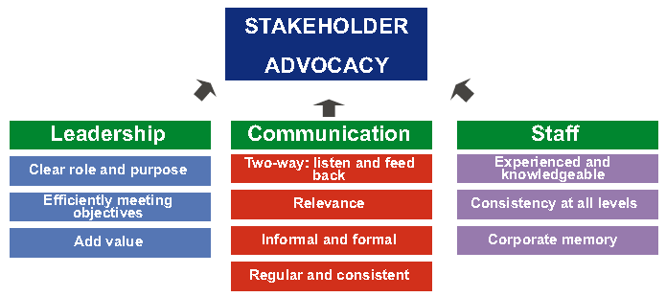

**3-1 What is your management style?**

**3-2 What makes you a world-class leader?**

Consultative, professional, respectual, hands-on, persistent

**4 Challenges of migration projects, e.g. M&A projects?**

➊Familiarize with new environment ➋Determine correct migration, upgrade path ➌Determine new environment requirements (resources, system) ➍Plan testing ➎Allow time for performance tuning ➏Set up training environment ➐Plan for backup & recovery

**5 How do you hold team members accountable?**

➊Handbook (scope, procedures) ➋Clear role ➌Measurable performance criteria ➍Meeting, communication

**6 How do you handle unhappy stakeholders or clients?**

➊Involve stakeholder in prioritization of requirements ➋Ensure business sign-off of charter and requirements ➌Ensure minimum weekly face-to-face meeting on progress ➍Invite business to (some) project status meeting

**7 How do you handle excessive work demand for your group?**

➊Acknowledge team extra effort ➋Inform business of related risk ➌Review risk log and approach to remedy ➍Review plan/workflow to identify bottleneck

**8 What do you think would challenge you in this position?**

➊Engage stakeholder ➋Optimize team performance ➌Detect/ correct problems on time

**9 How do you handle very poorly performing project staff?**

➊Diagnose poor performance ➋Enhance ability (Resupply, Retrain, Refit, Reassign, Release) ➌Improve motivation (performance goals, assistance, feedback)

**10 Your top 3 recommendations to manage world class PMO?**

➊Engage stakeholder ➋Optimize team performance ➌Continuous improvement

**11 How do you motivate?**

➊Be realistic and specific ➋Create a safe environment (shield from org politics) ➌Be a role model ➍Know the team members ➎Recognize effort, progress, contributions ➏Celebrate ➐Empower ➑Link project success to corporate strategy – Get recognition from senior management

**12 How do you negotiate?**

➊Know your opponent ➋Know the subject to negotiate ➌Know your BATNA

**13 Leading organizational change management**

…on projects whose benefits relied significantly on high degree of behavioral changes

*Change Management*

➊Shared understanding of reality of change ➋Formulate the change ➌Plan the change ➍Implement the change ➎Manage change transition ➏Sustain change

***Promoting Behavior Changes***

➊Increase benefits ➋Decrease costs ➌Decrease the desirability of competing alternatives ➍Socially Desirable ➎Easily Done ➏Seek Sr. Management blessing

***Types of Resistance to changes***

➊**Technical resistance** ➀**Habit & Inertia** (bureaucratic traditions vs. new ways) ➁**Fear of the Unknown** ➂**Prior investment** (fear of waste)

➋**Political resistance** ➀**Resource allocation** (doing more with less) ➁**Leaders indictment** (full responsibility over the overloading of market risk system) ➂**Threats to powerful coalitions** (C-M Operations & IT)

➌**Cultural resistance** ➀**Old cultural mindsets** (CIBC/HOOPP gung-ho trading, AIG dominance) ➁**Sense of security** ➂**Climate for change** (pension not in the crosshairs)

🕮**Fighting Resistances to Changes**🕮**Change Management in Portfolio, Program, Project** 🕮**Organizational Project Management (OPM3)** 🕮**Change Management at Portfolio Level** 🕮**Change Management at Program Level** 🕮**Change Management at Project Level**

**14 How do you resolve personal conflict?**

➊Be neutral third party ➋Establish rules of conduct ➌Meet both parties in calm & controlled setting ➍Control discussion ➎Understand perspectives ➏Reach working solution ➐Status Quo unacceptable

**15 How do you create alignment among partners?**

➊Create stakeholder matrix ➋Seek common understanding of project objectives (Project Charter) ➌Define detailed RACI chart ➍Ensure representation within the team ➎Ensure adequate communication plan

**16 How do you manage stakeholders?**

➊Identify ➋Prioritize ➌Understand their needs ➍Engage ➎Monitor engagement - Report project health

**17 How I support new staff?**

**Program/project handbook** ➊Program Scope ➋Program Approach ➌Program Management, Control Process ➍High Level Program Plan ➎Project Governance ➏Change Management ➐Roles & Responsibilities ➑Weekly Status Report Process ➒Centralized Issues Log ➓Project Control Mechanism

**18 What I did when I screwed up?**

➊Assess the damage ➋Admit your mistake immediately ➌Be direct and unambiguous ➍Take responsibility with humility ➎Take a step back and breathe ➏Don’t throw others under the bus ➐Devise an action plan ➑Do everything in your control to make it right ➒Prepare yourself for the consequences ➓Don’t be too hard on yourself

**19 What did you do when the project is behind schedule?**

➊Work overtime➋Reallocate resources (critical path) ➌Double-check dependencies ➍Check time-constrained activities (sign-off, training) ➎Swap resources ➏Crash schedule (increase resources) ➐Fast track it (make sequential partially or totally parallel) ➑Prevent all scope change ➒Improve processes ➓Scale back the scope of work

**20 What did you do when the project is over budget?**

➊Work unpaid overtime ➋Swap human resources ➌Eliminate or replace non-labor costs ➍"Zero tolerance" scope change ➎Use budget contingency ➏Scope back the work

**21 Basic Requirements for controlling project**

➊**Plan** (realistic, credible, detailed enough to be executed, acceptable to those who must execute it, approved by those who are accountable (SRO/ Project Board) ➋**Process for monitoring/ managing** progress & resource usage ➌**PM organisation** (skilled people with sufficient authority & time to plan, monitor, report, take decisions & deal with exceptions ➍**Process for minor corrections & adjustments** (minor deviations & omissions) ➎**Commitment** to provide resources (SRO, Project Board, Stakeholders, resource ‘owners’) ➏**Explicit authority** to proceed by accountable (SRO/ Project Board)

## Experiences

|  |  |
| --- | --- |
| •**15 yrs** in portfolio management; **$100M portfolio of 100** programs and projects.  •**20 yrs** of program/ project management + developing/ deploying project management standards, processes, tools for project delivery and **budget** and **benefits**, **system integration**  •Manage/ report scope, time, cost, risk, resources, quality in programs exceeding **$50M** of **$15M** with **10** concurrent projects and teams **120** resources and **20** vendors  •Formulated corporate IT strategy for **CIBC**: $80M 3-yr upgrade financial risk system for $2B reduced Regulatory Capital; **CIBC Mellon**: $6M 2-yr integration financial system for revenue of $350M and 1,300 employees; and **AIG** $10B in revenues 120% explosive expansion into China, India, VN •Delivered AIG’s **4 strategic objectives** at $70M in costs per objectives, inventory of 9 regional initiatives; prepared business cases and effective ranking, prioritizing, approving and executing projects  •Created an inventory of **9 i**nitiatives supporting **4 x** **$70M** strategic objectives; established rigorous financial procedures for business cases and project ranking, prioritizing, approving and execution  •Strategy **for e-services** for 10 Australian industrials combined export of $50M to 20 countries in Asia and Middle East  •**Tier-1 consulting** projects for business transformation, process reengineering, compliance, infrastructure, development  •**Projects rescue** (Capital Markets, Credit Cards, Retail Loan, ***Wealth***, ***Treasury***, Payment, Business Intelligence, Insurance) and public services (BColumbia Corporate Accounting Services, MTO, Australia HCS)  •Implemented **Governance Methodologies** (Sarbanes-Oxley Act, COSO, COBIT, ValIT, CMM, RiskIT, ISO, ITIL); re-designed mgt processes for 5 departments (operations, middle office, back office, finance, IT) 200 members/ staff and established more than 4,000 process controls (SOX) at CIBC | **5 business units and 7 stakeholders financial/compliance** standards: IFRS (HOOPP), GAAP (MANULIFE), BASEL II&III (CIBC), SOX (CIBC, AGNICO)  •Built consensus with senior leaders, management and staff. Team motivation, mobilization, building complex relationships among business lines, internal staff and vendors. Expert in identifying stakeholders expectations, and aligning them optimally  •Set up **Project Management Office** at AIG, CIBC (Financial Risk), [CIBC Mellon](#_(CIBC_Mellon_(ERP,), SIERRA, HOOPP, CBOC •Portfolio management, **Program management**  •Within PMO, mentored and managed **15 program and project managers**  •Engaged various business units for adoption and maturity of program and project management disciplines  •Defined **PMO policies and procedures** with the focus on transparency and alignment with strategic objectives for all programs and projects in the portfolio  •Defined **governance processes** around Portfolio and Project Management tools then evaluated, deployed and institutionalized **CA Clarity** and **PLANVIEW** systems  •Established policies, procedures, processes, tools & templates for portfolios, programs, and projects Metrics, **estimation**, **Balanced Scorecards**, **Strategy Maps,** **Activity-Based Costing (ABC)** and **Earned Value Management**. Developed project accounting practices and managed Project Financials using Scotia Bank SMARTSTREAM, Project Reporting Facility  •Expert with Program, Project Management methodologies including PMI’s Standard for Portfolio/ Program/ Project Management; Ontario Public Service Unified Project Management Methodology, Oracle Application Implementation Methodology, others (Scotia, CIBC, AIG, PwC), **AGILE****,** **RUP**, **SDLC****,** **SIMCORP**  •**Project rescue missions** •**project auditing** •scope management •**vendor selection** • **vendor management** (RFQ, RFP, contract negotiation, SLA, performance monitoring) •Project governance •Business requirements  •Business process transformations, enterprise risk, change management: assessed current state, defined target state, implemented gaps for org. changes |
| •Work with clients to define/ **manage scope, strategy, and requirements** of projects  •Work with clients to manage **implementation** of projects  •Develop **cost benefit** analysis  •**Complete** projects within budget/ timelines while meeting client business objectives | •Identify and analyze project **risks**  •Mitigate, document, control project **risks**  •Develop and deliver **budgets**  •Identify **resource** needs for project  •Establish **roles, expectations, and goals** for team members  •**MS PROJECT**, **SHAREPOINT**, **EXCEL**, **ACCESS** |

***Action Verbs***

Refreshed the **PMO engagement model** - Designed and deployed - Led oversight and execution - Designed new processes - Provided a foundational baseline of - Developed cross-functional change management governance models - Set expectations, facilitated initial knowledge transfer and managed on day to day basis efforts - Managed Mutual Funds Project, resulting in updates to 100% of procedures (**80 existing procedures, 130 new procedures**), and in updates to more than **40 mutual fund products**- Defined I&IT **Project Portfolio**; Defined I&IT **Portfolio and Project Management policy**; Established I&IT **PMO strategy, guiding principles, functions, org structure, staffing and career paths, Checkpoint and Gating guidelines**, Established resource management process and supporting tools, Created a set of **43 Project Management artifacts**, including **process maps, document templates**, guidelines and process guides for **Initiation, Planning, Execution and Closeout** phases defined in the methodology. The artifacts covered Project Management (**Project Tailoring Guidelines, Project Charter, Project Schedule, Project WBS, Project Management Plan, Project Estimation Guidelines, standardized rates**, others), **Business Analysis, Solution Architecture, Quality Management** and other areas; Facilitated implementation of the **Project Intake Process** to standardize assessment / ranking of 6 new project and program requests per month

## INTERVIEW QUESTIONS

**INTERVIEW QUESTIONS TO ANTICIPATE:**

What interests you most about the company?

What interests you most about the job description?

Describe yourself.

Describe yourself in 2-3 words.

Why do you feel you would be the best candidate for this position?

What are your strengths/weaknesses?

What would your current boss say your strengths are?

What changes have you made to make yourself more effective at work?

What areas do you feel training would be beneficial?

Describe a difficult situation at work and how you handled it.

What motivates you?

Give me an example of a time you procrastinated and how you handled it.

Give me 2-3 process improvements you identified and implemented.

How do you set priorities?

Describe your most successful manager.

If you could start your career all over again, what would you do differently?

**INTERVIEW QUESTIONS TO ASK:**

What have you enjoyed most while working at XYZ company?

What have been your largest accomplishments at XYZ company?

How has turnover been within the company?

How much growth within the department and company have you seen since you have been on board?

Do you think the departments collaborate well within the organization?

Does the company typically promote from within?

What is the accounting department like?

What are the most important attributes for the person to succeed in the position?

What skills are currently missing on the team that you look for in a new hire?

What are the most important projects for this position over the next few months?

What are the biggest areas for growth within the company within the next year?

What are the biggest challenges for the company and accounting department?

Anything that concerns you about my background being a good fit for this role?

**GENERAL**

1. Tell me about a time where you had to manage change. How did you do it, and what was the outcome?
2. How would you describe your management style?
3. How would you describe your ability to communicate with senior management?
4. What qualities make a good boss or manager?
5. What are your greatest attributes as an employee?
6. What are your career goals?
7. In your last performance evaluation, where were your areas for improvement?
8. Why did you leave your previous employer, or why are you leaving your present job?
9. Where do you hope to be in five years?
10. Which of your past jobs was the most interesting?
11. Which of your past jobs was the least interesting?

**BEHAVIORAL**

1. Describe a recent situation in which you imparted your key points to a group with varying verbal skills?
2. Describe a time when you communicated something unpleasant or difficult to say to your manager. How did you assert yourself?
3. Give me an example of a time when you confronted a negative attitude successfully, which then resulted in building teamwork and morale.
4. Tell me when you had to “stand up” for a decision you made even though it made you unpopular.
5. Tell me about a time when you showed high enthusiasm and energy in order to create a positive energy in others. Give a specific example.
6. What is your viewpoint about co-workers that never speak their mind?
7. What sources of information have provided you with the best data for decision making?

**PERFORMANCE-BASED**

1. What are you looking for in a new job?
2. Why is having “x” and “y” important to you, and why do you think that this job meets that criterion?
3. Tell me about your schooling and advanced training.
4. What is your major project or accomplishment ?
5. Tell me about a major team accomplishment; consider one where you led a team and one when you were a key member of a team.
6. One major problem we are now facing is “xyz”. How would you go about addressing this? a. What would you need to know, and how would you plan it out? b. What have done that is most similar to this?
7. While I’ve seen a few other strong candidates, I’m impressed with some of the work you’ve done. What are your thoughts now about this job? Is this something that you’d consider further? Why or why not?

**FACT FINDING**

1. Describe a significant work challenge that you’ve had to overcome. Why was it significant?
2. What were the actual results?
3. When did this take place and at what company?
4. How long did it take you to complete the task?
5. What was the situation when you took on the project?
6. Why were you chosen for this role? Did you volunteer?
7. What was your actual title?
8. Who were the people on the team?
9. What was your supervisor’s title?
10. What technical skills were needed for the task?
11. What skills were learned? Describe the planning process, your role in it, and whether the plan was met. Provide details of what went wrong and how you overcame them. What was your role in this project?
12. Give me 3 examples of where you took the initiative?
13. What were the biggest changes or improvements?
14. What was the toughest decision you had to make? How did you make it? Was it the right decision? Would you make it differently looking back?
15. Describe the environment – the pace, the resources available, your boss, the level of professionalism.
16. What was the biggest conflict you faced? Who was it with and how did you resolve it?
17. Give me some examples of helping or coaching others.
18. Give me some examples of where you really had to influence or persuade others to change their opinion.
19. How did you personally grow as a result of this effort?
20. What did you like the most and least?
21. In retrospect, what would you do differently?
22. What type of recognition did you receive for this project? Was it appropriate in your mind?

**INTERPERSONAL SKILL**

1. **Emotional Self-Awareness** – the ability to recognize and understand one’s feelings and emotions, differentiate between them and know what caused them and why.

•Benefit in the Workplace? Good emotional self-awareness promotes conflict resolution and leads to improved interaction between staff. Is it easy for you to know when you are getting anxious, scared, annoyed, or angry? Can you give me an example or explain to me how you know this? What things do you feel really happy about? Why? What things do you feel really sad about? Why?

**2. Assertiveness** – ability to express feelings, beliefs and thoughts and defend one’s rights in non-destructive manner.

•Benefit in the Workplace? Proper assertiveness helps individuals to work more cohesively and to share ideas effectively. When you disagree with someone, what do you typically do? Give me an example of when you did that? Do you have difficulty standing up for your rights? Give me an example of when you did. When someone’s behavior consistently bothers you, how do you usually react? Can you give me an example of when you dealt with this situation and how you handled it?

**3. Self-Regard** – To respect and accept oneself as good.

•Benefit in the Workplace? Employees who have a high self-regard have better work attitudes and behaviors. Better self-confidence means better performance. What are your strengths, and how do you use them to your advantage? Can you give me an example? What are your weaknesses and what are you doing to improve them? Can you give me an example? Describe what kind of person others would say you are. Why?

**INSIGHT INTO BEHAVIORAL-BASED QUESTIONS**

4. **Self-Actualization** – To realize potential capabilities and to strive to do that which one wants to do and enjoys doing.

•Benefit in the Workplace? High self-actualization is connected with good motivation + team performance. What are your short-term goals and long-term goals? What are you doing to accomplish these goals? How actualized do you feel you are? Why? What things interest you and why?

5. **Independence** – The ability to be self-reliant and self-directed in one’s thinking and actions and to be free of emotional dependency.

•Benefit in the Workplace? Independence increases productivity and efficiency in work flow and the ability to meet milestones + goals in a timely manner. How do you make difficult decisions? Give me an example of a difficult decision that you had to make and the process you used for making it? Do you need people more than they need you, or the opposite? Why? What interest you and why?

6. **Empathy** – the ability to be aware of, to understand, and to appreciate the feelings of others. It is “tuning in” to what, how and why people feel the way they do.

•Benefit in the Workplace? This creates a more cohesive, functioning team and better team players. How difficult or easy is it for you to understand how people feel? Do you usually know when you have said or done something that has offended someone? How do you know? What do you do about it? Can you give me an example of a time when you felt you might have offended someone? What did you do?

7. **Interpersonal Relationships** – to establish and maintain mutually satisfying relationships that are characterized by intimacy and by giving and receiving kind gestures.

•Benefit in the Workplace? Good interpersonal relations translate into effective communication within and between departments and groups. When you are in a social situation with people you don’t know, what do you typically do? What is the basis for a good relationship in your opinion? What are the ingredients that go into it? Tell me about a relationship that is meaningful to you and what do you do to try and maintain it?

8. **Social Responsibility** – To demonstrate oneself as a cooperative, contributing, and constructive member of one’s social group. This involves acting in a responsible manner although one may not benefit personally.

•Benefit in the Workplace? Social responsibility means recognizing departmental and company goals and contributing to these goals. Can you give me an example of a situation where you considered the needs of others, possible to your own detriment? Give me an example of how you behave as a team member?

**ADAPTABILITY SKILLS**

9. **Problem Solving** – to identify & define problems as well as to generate and implement potentially effective solutions.

•Benefit in the Workplace? The method used for problem solving is critical: viable alternative solutions must be considered, including cost / benefit analysis and long term implications, as examples. Can you give me a step-by-step example of a difficult situation that you handled at work or at home? Is it generally easy or difficult for you to come up with a number of possibilities for approaching a problem? How easy or difficult is it for you to decide on the best solution and implement it? Can you give me an example?

10. **Reality Testing** – the ability to assess the correspondence between what is experienced (the subjective) and what in the reality exists (the objective).

•Benefit in the Workplace? It is important to focus on practicality and not on unrealistic expectations. Do you usually assume things and jump to conclusions, or do you check things out before acting? Can you give me an example? Would others say you are realistic or idealistic and why? Can you give me an example of that?

11. **Flexibility** – to adjust one’s emotions, thoughts and behavior to changing situations and conditions.

•**Benefit in the Workplace?** Employees perform better in positions where tasks are dynamic and changing. Low flexibility resources perform better in more well-defined tasks requiring reliability and consistency. Can you give me an example of when your opinion about a person or situation was clearly wrong and what you did? Give me an example of how well you deal with change in general? If you were forced to leave your home, how would handle it?

**STRESS MANAGEMENT SKILLS**

12. **Stress Tolerance** – the ability to withstand adverse events and stressful situations without “falling apart” by actively and positively coping with stress; the ability to weather difficult situations without getting too overwhelmed.

•Benefit in the Workplace? Effective stress tolerance has to do with managing reasonable workloads, establishing clear priorities and meeting realistic deadlines. What tactics do you use to cope with everyday stress? Give me an example of a stressful situation that you coped with effectively?

13. **Impulse Control** – the ability to resist or delay an impulse, drive, or temptation to act. It entails the capacity for accepting one’s aggressive impulses, being composed, and controlling aggression, hostility and irresponsible behavior.

•Benefit in the Workplace? Rash actions can be costly. Mistakes can often be avoided simply taking the time to stop and think things through. Can you give me an example of a situation in which you were very angry and what you did in that situation? How do you typically deal with an impulse or temptation to act prematurely?

**GENERAL MOOD**

14. **Happiness** – the ability to feel satisfied with one’s life, to enjoy oneself and others and to have fun.

• Benefit in the Workplace? Positive moods lift spirits, create resonance and help overall performance of individuals and teams. If I were to ask your friends how you make them feel when they are around you, what would they say? Why? Are you generally satisfied with the way things are presently going in your life? Why?

15. **Optimism** – to look at the bright side of life and to maintain a positive attitude, even in the face of adversity.

•Benefit in the Workplace? An optimistic attitude helps ward off stress while creating resonance that increases one’s productivity. How do you typically deal with failure? Can you give me an example of a time where, in your opinion, you failed? How did you deal with the situation? How do you cope with your pessimistic feelings?

**NASA Shared Voyage**

•Projects usually present a bundled set of challenges demanding that people operate in both known and new domains at the same time. The known domains are amenable to technical expertise and managerial authority. The new challenges - ***adaptive challenges -*** require leadership that can handle the conflict and messiness of ongoing structural tensions across different organizations and groups as they strive for collective innovation.

➊**Adaptive leadership is active and reflective**: constantly alternate between participating and observing; be part of the action and yet also rise above it to analyze more clearly changing landscapes requiring ongoing corrective action; be able to “get off the dance floor and get on the balcony.” •**Adaptive processes in evolutionary biology are experimental**. Rather than investing the knowledge in high authority, which makes sense for technical problems, adaptation is more likely to succeed with a distributed intelligence.

➋**Adaptive work generates tough trade-offs between legitimately competing claims**, “the difference between ‘desirements’ and requirements.” •Discovering which trade-offs to make requires drawing out divergent perspectives, orchestrating conflicting views and interests, and listening for the crystallization of a good idea rather than reaching too quickly for decision. •But trade-offs are painful. Jobs are lost, people are let go. Casualties are often necessary. Have the stomach to deliver bad news, and the heart to deliver it well.

➌**Leadership is a political activity, even in projects**. When people make the classic leadership error of treating adaptive challenges like technical problems, they end up assuming too much about the relevant stakeholders and then step on toes unwittingly. Everybody has a piece of the turf, and you’d best respect that. You never know how much your lack of respect may cost you.

➍**Leadership is about challenging people to take far-reaching responsibility.** The task is to put the creative work back in people’s laps when parochial views inhibit new thinking and necessary collaboration. “I don’t know how you’re going to figure this out, but I have confidence that you will, and if you don’t, we all fail.”

➎**Adaptive work takes time**. Within days, we can complete the analysis that was the technical part of the problem-solving. The implementation, on the other hand, took months because implementation consists of changing people’s hearts, minds, and habits of behavior. People will either sustain the direct loss of their own job, the indirect loss associated with a friend or colleague losing their job, or the loss of competence for a period of time during which they must learn new competencies. Closer to where the tire hits the road, implementation is more than execution, it demands of people that they face some losses and learn new ways.

➎**Leadership infuses the work with meaning**. People are willing to take risks, and even pay dearly, if the stakes are sufficiently meaningful. Money is only part of it

# MICROSOFT AGILE (FORBES)

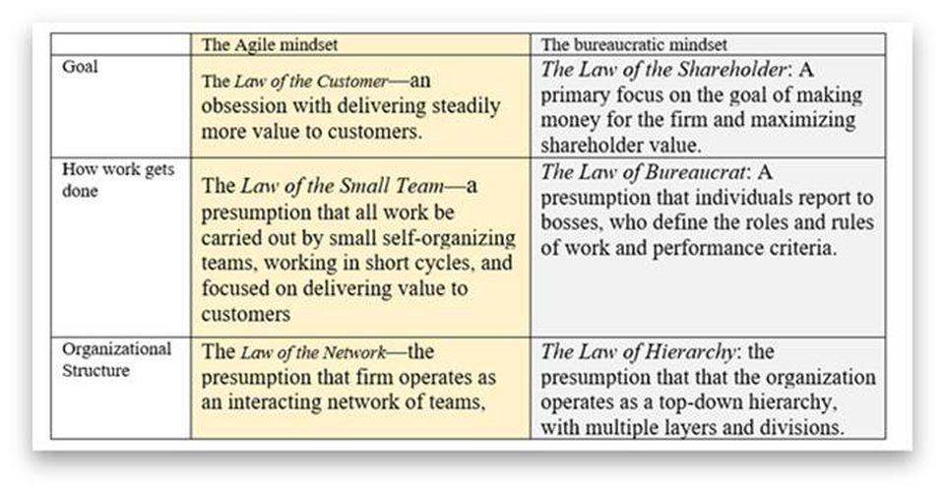

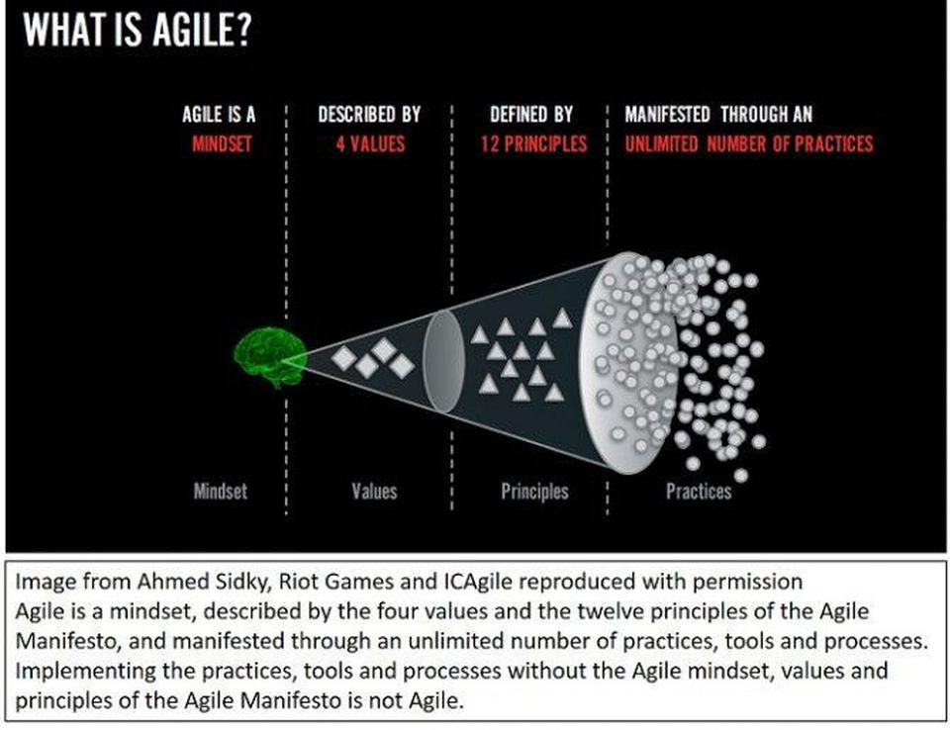

#### ➊Pursue “Agile at Scale,” not “Scaling Agile”

Tight focus on delivering continuous value to customers, not merely generating quarterly profits or boosting the current stock price. It also rests on a deep respect for the talents and capacities of those doing the work, and the teams in which they work, not treating workers as “resources" that are assignable, optimizable and ultimately disposable.

#### ➋Take Care of Planning and Coordination

Planning begins with an overall vision for the product. Then a program manager like Aaron develops and owns what is called a “scenario,” which is the goal for the product for the next 18 months. It’s a story of where the program wants to be 18 months from now. The story can include other teams. The group has about a 60% confidence in its ability to predict what the customers want to and to deliver that. The year is broken up into two seasons, called “spring” and “fall”. At all times, each team maintains and owns a thoughtful and detailed three-sprint plan, each sprint comprising three weeks. The team always has a good idea what’s in store for the next three sprints.

#### ➌Get the Right Balance of Alignment and Autonomy

Alignment at the top and autonomy at the bottom. The teams need autonomy. That’s what drives them to come to work and deliver great stuff. But at the same time, their work has to be aligned with the business.

#### ➍Master The New Role of the Manager

What happens when a team misses a sprint? A manager doesn’t monitor a teams’ burn-down charts. The burn-down charts are for the teams. If they get behind, guess what they do? They talk about what to do. That’s the behavior the manager wants

#### ➎Handle Dependencies At The Team Level

Every three months, there's a standing meeting across all of the teams. It’s called “a feature team chat.” Every team comes in and shares their plan.

#### ➏Ensure Continuous Integration

Continuous delivery has meant more modularity in design and a change in architecture. The teams use what they call “feature flags.” Here's a high level description of how it works. If they are going to do something new, the very first thing that they do is to isolate the code that they are changing and build a switch into the code. It is powered by a flag in the database. It’s a configuration change. When the team writes code, they write it behind the safety of the flag. At some point, when they feel it’s ready, they can turn it on just for the team. That switch is not a global switch. It’s a switch for an account in the system just for the team. If that goes well, then the team can turn it on for certain customers. Those customers can see it and try it. They help the team find bugs and problems. When the team gets through all that, and the team thinks it’s really ready, they prepare the release notes and an announcement that they are going to flip the switch for everybody. Then they go back and refactor the old code out. This enables the teams to work alongside each other on the same code without breaking one another’s work. At the end of every sprint, the team sends out an email to all 450 people in the Visual Studio Online group and the leadership team. They talk about what they accomplished that sprint and what their plan is for the next sprint. And they record a 3-5 minute video. (Warning: the videos can get fancy, if the teams have aspiring Hollywood directors.) The video replaces the sprint demo.

#### ➐Keep On Top Of Technical Debt

“Now the bugs never grow. There 's a Key Performance Indicator (KPI) we call 'the bug cap.' It’s the number of engineers on your team times four. So if you have ten engineers, your bug cap is 40. If you get to 40 bugs, the team needs to stop work on new features and the next sprint, get the bug count back down below 40. It’s self-managing.

#### ➑Embrace DevOps and Continuous Delivery

Development and operations merge. The teams own the planning of each new feature. They own the execution of the feature. They own the delivery the feature. And they own the operation of the feature. The change in time frame makes a big difference. A deadline now is three weeks. Three weeks is no big deal. Before you had only two opportunities., and if you missed it, you had to wait two years. Now if it’s not high quality, you don’t push it out. You hold it. It’s disappointing that you didn’t get it out. You talk about it in your retrospective. Did you do something wrong? Or did you just underestimate the level of complexity? Did you miss something? It’s better to have that conversation than to have a fire-drill and punish the team for not delivering what they promised, or worse, pushing out a poor-quality product.

#### ➒Continuously Monitor Progress

The teams do a great deal of monitoring how the features are being used. The results flow into the aspirational backlogs, which are called scenarios. Every month, the program manager reports out on metrics, on the accounts using different aspects of the service. So the group is learning to become a data-informed business. They don’t call it “data driven” because that would run the risk of missing the big picture. They use their brain and their gut feel as well as being informed by the data. The data isn’t an after-thought though. It’s often the first part of the conversation. Part of the very definition of “done” is having the right telemetry. The teams see this data and monitor it both when they are testing it and as soon as it goes live. It’s not something they do in the sprint after they ship it. It’s part of the acceptance criteria to ship.

#### ➓Listen To Customer Wants, But Meet Their Needs

The teams don’t blindly follow what customers say. They have what they call "the cookie principle." If you have a plate of cookies and you ask people if they want one, they will say yes. No one turns down a cookie.

#### ➊Deal With Directions from Above

There is very little load balancing among teams. If a team gets behind, they don’t break up the team or move individuals to the team to fix it. They ask the team itself to fix the problem. They try to keep the teams together for 12 or 18 months. That’s what the teams themselves like. The firm is making an investment in the team for at least nine months or a year.

#### ➋Use Self-forming Teams To Encourage Team Ownership

Managers let people choose which team to work on. People can reshuffle every 18-24 months. Around two thirds of the team members decide to stay where they are. As a result, there are not many brand new teams. But the team members have the choice. The result is a significant investment in persistent teams. Quite apart from team well-being, it leads to higher performance. The team owns the backlog. Of course, there is a lot of discussion about priorities. But a manager doesn’t tell the team what should be next on the Kanban board.

#### ➌Recognize that The Team is the Product

Microsoft has an advantage: it had teams, long before they went Agile. There was already a strong team culture. It’s more difficult for firms going Agile that don’t have a history of teams.

#### ➍Build Quality From The Beginning

In the first sprints, there was agreement on 3 week sprints. The leadership signed off on the idea of Agile and Scrum, but they were a little worried as to how it was going to work. So they planned for "a stabilization sprint" after five sprints. The goal is to avoid the sequence: write code in the first sprint. Test it in the second sprint. Fix bugs in the third sprint. The rules of the road are: deliver finished product every sprint.

#### ➎Use Coaching Carefully

External coaches and trainers at Microsoft were noticeable in the site visit by their absence.

#### ➏Ensure Top Level Support

To achieve Agile at scale, the support of corporate vice-president, Brian Harry, has been central. Aaron has had the benefit of living in the Developer Division where Scrum and Agile practices now have a deep foothold. The Visual Studio group is leading the charge for Microsoft as a whole. It owns the “first party engineering system charter” (IES) and is driving that across the company. There are monthly scorecards on how the big divisions are doing in adopting it.

# AIG AUDIT

## FCU

⬩**ELC** (Entity Level Control) ⬩**OSP** (Outside Service Providers) Oversight ⬩**LU**= Least (privileged) User Access ⬩**NTE**= nature, timing and extent ⬩**SSAE16 SOC1, SOC2** ⬩**Audit Writing 5C’s**: Criteria (what should be), Condition (the current state), Cause (the reason for the difference), Consequence (effect), Corrective action plans/recommendations.

## PWC

#### Key Reports

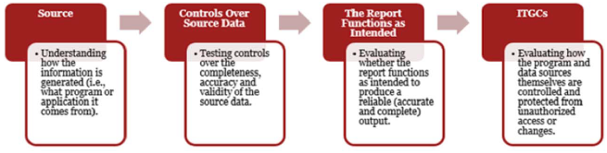

##### Accuracy & Completeness Procedures

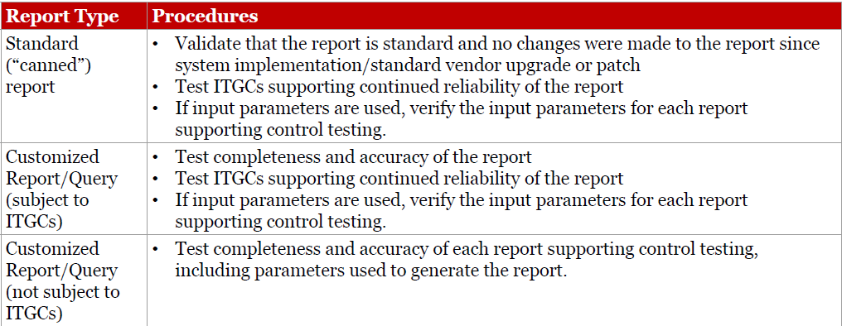

##### Full/False Accept/Reject Testing

• To assess whether the data included in the report is accurate, select a sample of items from the report and agree key attributes within the report to the underlying system.

• To assess whether the data in the report is complete, select a sample of items (different to the one used to test accuracy) from the system and confirm that those items are included in the report using unique key attributes.

##### Using a data extract, reperform the report/query

• Obtain an understanding of the logic used to generate the report.

• Observe the extraction of the data and confirm that the extraction is complete and apply the logic obtained

• Compare the result to the contents of the report used in management’s control to replicate the output by running independent queries on the extracted data on the back end database and match to the output on the report.

##### Perform an independent code review

• Assess the technical report logic to determine whether the report is generated as intended (i.e. combination or exclusions)

• Utilize sufficient technical ability and knowledge to formulate an independent point of view on the sufficiency of the code to satisfy the intended purpose, including both simple query languages (i.e. SQL) and complex mainframe programming languages (i.e. COBOL)

• Even code written in a simple query language may be complex, affecting the ability to efficiently perform a code review

#### System Interfaces

##### Interfaces Considerations

• What are the ways in which data flows from source system to target system, including pass through systems?

• What is the type of data being sent over the interface, and any specific key attributes? Is the data being modified (e.g. filtered, excluded, aggregated) during the transmission?

• How often is the job executed/its frequency for the purposes of the control?

• Where is the job configuration held, either in the source or destination application, or in a job scheduler like AutoSys? Is it subject to relevant ITGCs?

##### Interface – Interface Job Testing

• Identify the interface job and obtain job details and configurations

• Identify and test controls for handling job abends for the job

• Perform procedures over continued operation of the interface during the period

##### Interfaces – Testing Completeness

• Extract from source application of the file(s) being sent to destination application, including completeness considerations (e.g. script review and analysis)

• Extract from the destination application of the file(s) received from source application, including completeness considerations (e.g. script review and analysis)

• Reperform the interface by comparing the source file (e.g. total entries, total balance) to the file received in the destination application

##### Interfaces – Testing Accuracy

For a sample line item(s) selected from the destination extract:

• Obtain transaction details/key fields in the destination system

• Compare those key fields to the transaction details in the source system for accuracy

#### Automated Controls Considerations

• What are the various iterations in which the control can be configured and which ones are in use (e.g. calculation methods, validation checks, etc.)?

• What is the process for periodic validation of the system functionality?

• How and who can overwrite system functionality? And what is the process for implementing the changes?

##### Testing Automated Controls

• Gain an understanding and evaluate the underlying logic/functionality

• Perform a walkthrough of transactions to demonstrate the operation of the functionality is consistent with business purpose.

• Perform positive and negative scenario testing for each functionality

• Perform testing over each iteration of the functionality

#### Testing Automated Reconciliations

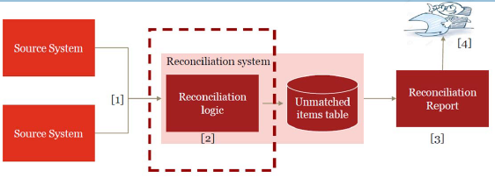

##### Reconciliations Considerations

• How the reconciliation is performed (automated vs manual)?

• What is being reconciled (i.e. cash, positions, balances, etc.)?

• What are the key fields being matched?

• Is the source data, including filtering criteria and exclusions, appropriate?

• How many iterations on the matching logic exist?

• What is defined as a break (tolerances/thresholds)?

• How are the results of reconciliation displayed (i.e. exception only, etc.)?

• What is the process for aging & resolution of the reconciling items?

• What is the monitoring over aged items?

##### Testing Automated Reconciliations

###### Method 1: Using source data/inputs

• Define Expectation: Obtain source data/inputs & apply necessary filters/exclusions based on systematic logic

• Define Outcome: Obtain results of reconciliation performed by the system (report, dashboard, etc.)

• Reperform Reconciliation: Compare the expectation from #1 vs outcome from #2

Testing Automated Reconciliations

###### Method 2: System Validation

1. Perform walkthrough to gain an understanding of the systems, feeds, and logic associated with the reconciliation

2. Define Expectation - Obtain Positive iterations and Negative iteration (data that matches/ does not match) and submit it into the application/reconciliation tool for processing

3. Define Outcome - Obtain results of reconciliation performed by system for both Positive iterations (which do not create reconciling items) and Negative iterations (which do create reconciling items)

4. Reperform Reconciliation - Compare results of expectation in #2 vs outcome in #3

5. Generation of Key Report - Test that reconciliation results appears completely and accurately Note: consider the effectiveness of ITGCS & test the continued operation of the control throughout the period

## Inshoring SOX functions



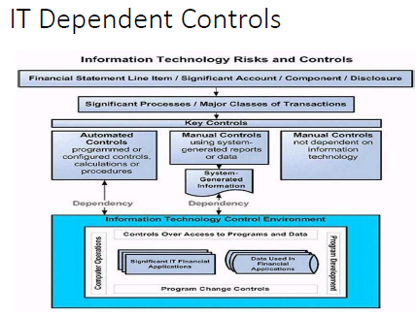



## RPA

⬩Initiated from Accounts Payable (NJ), DBA <Tax, FIS Billing, FP&A Planning&Analysis, Comptrollers> ⬩Consultant: GENPACT ⬩Process 1: Batch creation + Monies moving ⬩Process 2: VOID/STOP Payment (Reversal) ⬩Systems AWD (Automated Work Distributor Imaging & Workflow), OASYS PrC (Fixed annuity Admin) ⬩ RPA: OPENSPAN PEGASYSTEMS

## SOX Controls

NON-CLEARWATER; CLEARWATER

## SOC for Service Organizations

SOC for Service Organizations reports are designed to help service organizations that provide services to other entities, build trust and confidence in the service performed and controls related to the services through a report by an independent CPA.

#### SOC 1®– SOC for Service Organization: ICFR

*Report on Controls at a Service Organization Relevant to User Entities’ Internal Control over Financial Reporting* - These reports, prepared in accordance with AT-C section 320, *Reporting on an Examination of Controls at a Service Organization Relevant to User Entities’ Internal Control Over Financial Reporting,* are specifically intended to meet the needs of entities that use service organizations (user entities) and the CPAs that audit the user entities’ financial statements (user auditors), in evaluating the effect of the controls at the service organization on the user entities’ financial statements. Two types of reports:

* Type 2 - report on the fairness of the presentation of management’s description of the service organization’s system and the suitability of the design and operating effectiveness of the controls to achieve the related control objectives included in the description throughout a specified period.
* Type 1 – report on the fairness of the presentation of management’s description of the service organization’s system and the suitability of the design of the controls to achieve the related control objectives included in the description as of a specified date.

Use of these reports is restricted to the management of the service organization, user entities, and user auditors.

#### SOC 2® - SOC for Service Organizations: Trust Services Criteria

*Report on Controls at a Service Organization Relevant to Security, Availability, Processing Integrity, Confidentiality or Privacy* - These reports are intended to meet the needs of a broad range of users that need detailed information and assurance about the controls at a service organization relevant to security, availability, and processing integrity of the systems the service organization uses to process users’ data and the confidentiality and privacy of the information processed by these systems. Roles:

* Oversight of the organization
* Vendor management programs
* Internal corporate governance and risk management processes
* Regulatory oversight

Similar to a SOC 1 report, there are two types of reports: A type 2 report on management’s description of a service organization’s system and the suitability of the design and operating effectiveness of controls; and a type 1 report on management’s description of a service organization’s system and the suitability of the design of controls. Use are restricted.

#### SOC 3®— SOC for Service Organizations: Trust Services Criteria for General Use Report

These reports are designed to meet the needs of users who need assurance about the controls at a service organization relevant to security, availability, processing integrity confidentiality, or privacy, but do not have the need for or the knowledge necessary to make effective use of a SOC 2 Report. Because they are general use reports, SOC 3 reports can be freely distributed.

|  |  |  |
| --- | --- | --- |
| Key Question | Response | SOC Report Type Required |
| Will the report be used by your customers and their auditors to plan and perform an audit or integrated audit of your customer’s financial statements? | Yes | SOC 1® Report |
| Will the report be used by your customers or stakeholders to gain confidence and place trust in a service organization’s systems? | Yes | SOC 2® or SOC 3® Report |
| Do your customers have the need for and ability to understand the details of the processing and controls at a service organization, the tests performed by the service auditor and results of those tests? | Yes | SOC 2® Report |

***AICPA Toolkit for SOC for Service Organizations****To help service organizations better understand SOC for service organizations examination engaagements and educate current and potential customers on the reports on their controls, the AICPA has developed the*[*SOC Toolkit for Service Organizations*](https://www.aicpa.org/interestareas/frc/assuranceadvisoryservices/soctoolkit-serviceorgs.html)*. All materials are available as free downloads.* The AICPA has developed the "[Information for Management of a Service Organization](https://www.aicpa.org/content/dam/aicpa/interestareas/frc/assuranceadvisoryservices/downloadabledocuments/infoformanagementofsvcorg.pdf)" document to assist management of a service organization in preparing its description of the service organization’s system, which serves as the basis for a SOC 2**®**examination engagement. It is also intended to familiarize management with its responsibilities when it engages a service auditor to perform a SOC 2**®** engagement. This document was adapted from the AICPA Guide, *SOC 2****®****Reporting on Controls at a Service Organization Relevant to Security, Availability, Processing Integrity, Confidentiality, or Privacy (January 1, 2018)*.

# AUDIT SKILLS

## IIA standards

#### Standard 1210 – Proficiency

Internal auditors must possess the knowledge, skills, and other competencies needed to perform their individual responsibilities. The internal audit activity collectively must possess or obtain the knowledge, skills, and other competencies needed to perform its responsibilities.

**1210.A3 –** Internal auditors must have sufficient knowledge of key information technology risks and controls and available technology-based audit techniques to perform their assigned work. However, not all internal auditors are expected to have the expertise of an internal auditor whose primary responsibility is information technology auditing.

#### Standard 2010 – Planning

The chief audit executive must establish a risk-based plan to determine the priorities of the internal audit activity, consistent with the organization’s goals.

**2010.A1 –** The internal audit activity’s plan of engagements must be based on a documented risk assessment, undertaken at least annually. The input of senior management and the board must be considered in this process.

**2010.A2** – The chief audit executive must identify and consider the expectations of senior management, the board, and other stakeholders for internal audit opinions and other conclusions.

**2010.C1 –** The chief audit executive should consider accepting proposed consulting engagements based on the engagement’s potential to improve management of risks, add value, and improve the organization’s operations. Accepted engagements must be included in the plan.

#### Standard 2030 – Resource Management

The chief audit executive must ensure that internal audit resources are appropriate, sufficient, and effectively deployed to achieve the approved plan.

#### Standard 2100 – Nature of Work

The internal audit activity must evaluate and contribute to the improvement of the organization’s governance, risk management, and control processes using a systematic, disciplined, and risk-based approach. Internal audit credibility and value are enhanced when auditors are proactive and their evaluations offer new insights and consider future impact.

#### Standard 2110 – Governance

The internal audit activity must assess and make appropriate recommendations to improve the organization’s governance processes for:

* Making strategic and operational decisions.
* Overseeing risk management and control.
* Promoting appropriate ethics and values within the organization.
* Ensuring effective organizational performance management and accountability.
* Communicating risk and control information to appropriate areas of the organization.
* Coordinating the activities of, and communicating information among, the board, external and internal auditors, other assurance providers, and management.

**2110.A2 –** The internal audit activity must assess whether the information technology governance of the organization supports the organization’s strategies and objectives.

#### Standard 2130 – Control

The internal audit activity must assist the organization in maintaining effective controls by evaluating their effectiveness and efficiency and by promoting continuous improvement.

#### Standard 2200 – Engagement Planning

Internal auditors must develop and document a plan for each engagement, including the engagement’s objectives, scope, timing, and resource allocations. The plan must consider the organization’s strategies, objectives, and risks relevant to the engagement.

#### Standard 2201 – Planning Considerations

In planning the engagement, internal auditors must consider:

* The strategies and objectives of the activity being reviewed and the means by which the activity controls its performance.
* The significant risks to the activity’s objectives, resources, and operations and the means by which the potential impact of risk is kept to an acceptable level.
* The adequacy and effectiveness of the activity’s governance, risk management, and control processes compared to a relevant framework or model.
* The opportunities for making significant improvements to the activity’s governance, risk management, and control processes.

**2201.C1 –** Internal auditors must establish an understanding with consulting engagement clients about objectives, scope, respective responsibilities, and other client expectations. For significant engagements, this understanding must be documented.

#### Standard 2210 – Engagement Objectives

Objectives must be established for each engagement.

**2210.A1 –** Internal auditors must conduct a preliminary assessment of the risks relevant to the activity under review. Engagement objectives must reflect the results of this assessment.

**2210.A2 –** Internal auditors must consider the probability of significant errors, fraud, noncompliance, and other exposures when developing the engagement objectives.

**2210.C1 –** Consulting engagement objectives must address governance, risk management, and control processes to the extent agreed upon with the client.

**2210.C2 –** Consulting engagement objectives must be consistent with the organization's values, strategies, and objectives.

#### Standard 2220 – Engagement Scope

The established scope must be sufficient to achieve the objectives of the engagement.

**2220.A1 –** The scope of the engagement must include consideration of relevant systems, records, personnel, and physical properties, including those under the control of third parties.

#### Standard 2230 – Engagement Resource Allocation

Internal auditors must determine appropriate and sufficient resources to achieve engagement objectives based on an evaluation of the nature and complexity of each engagement, time constraints, and available resources.

#### Standard 2240 – Engagement Work Program

Internal auditors must develop and document work programs that achieve the engagement objectives.

#### Standard 2310 – Identifying Information

Internal auditors must identify sufficient, reliable, relevant, and useful information to achieve the engagement objectives.

## Audit Metrics

#### Frequency

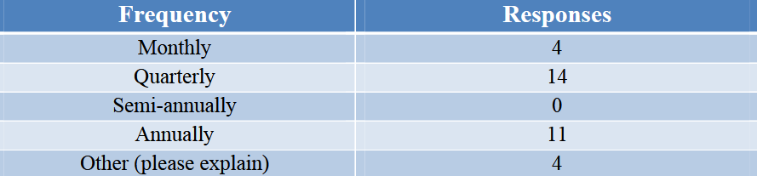

#### Environment

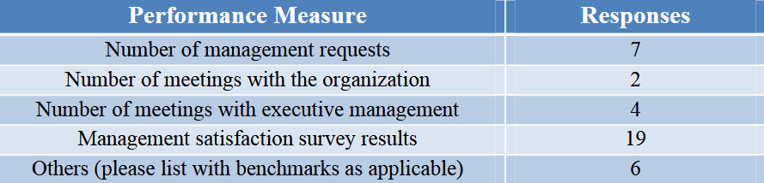

#### Output

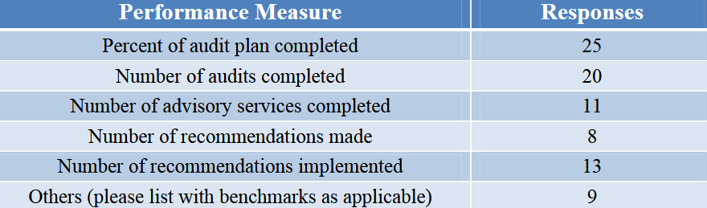

#### Quality

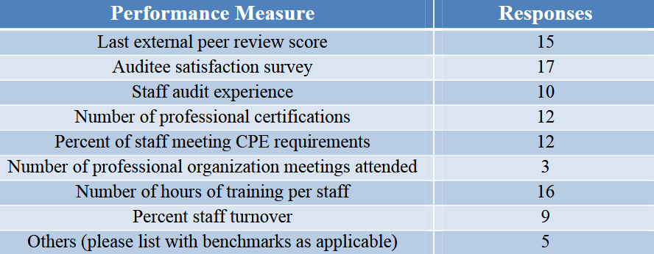

#### Efficiency

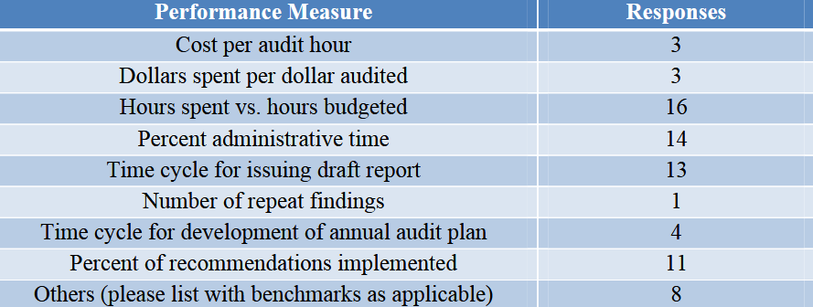

#### Impact

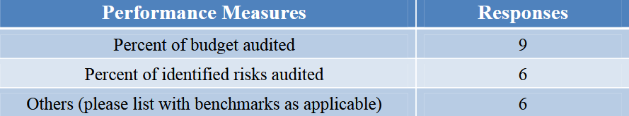

## Audit Acquisitions

#### Life Cycle

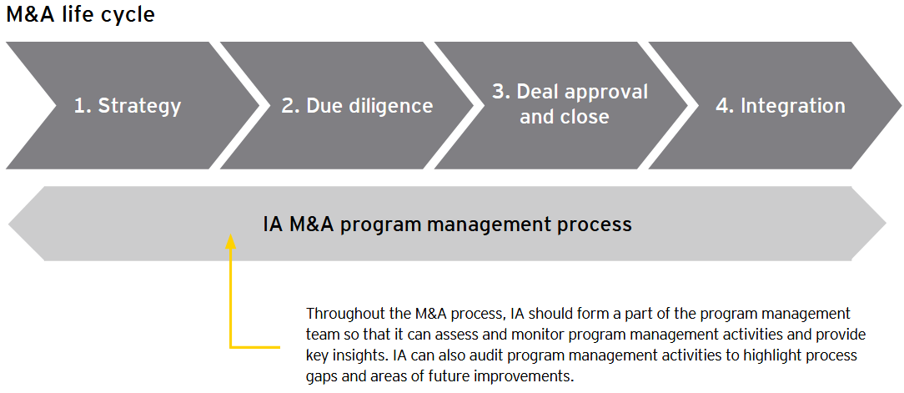

#### Strategy

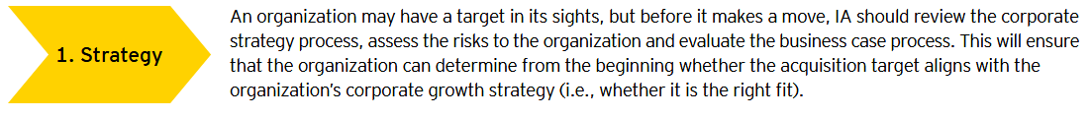

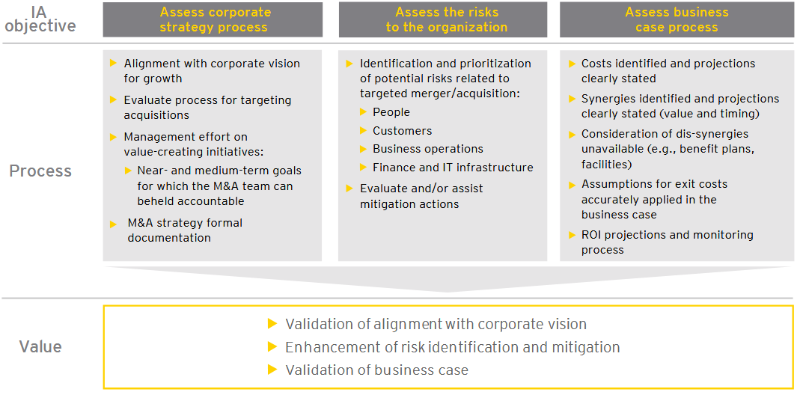

#### Due Diligence

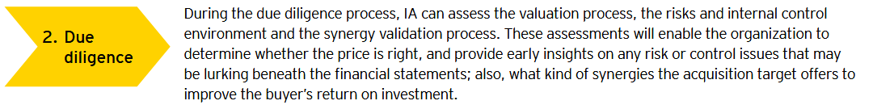

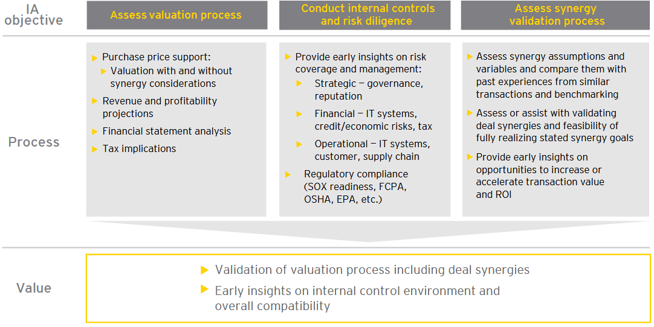

#### Deal Approval and Close

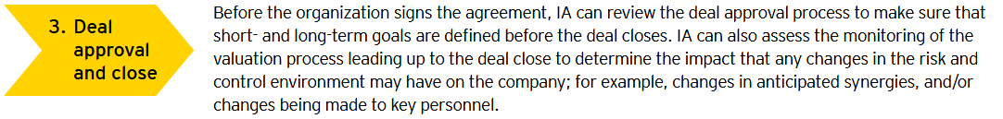

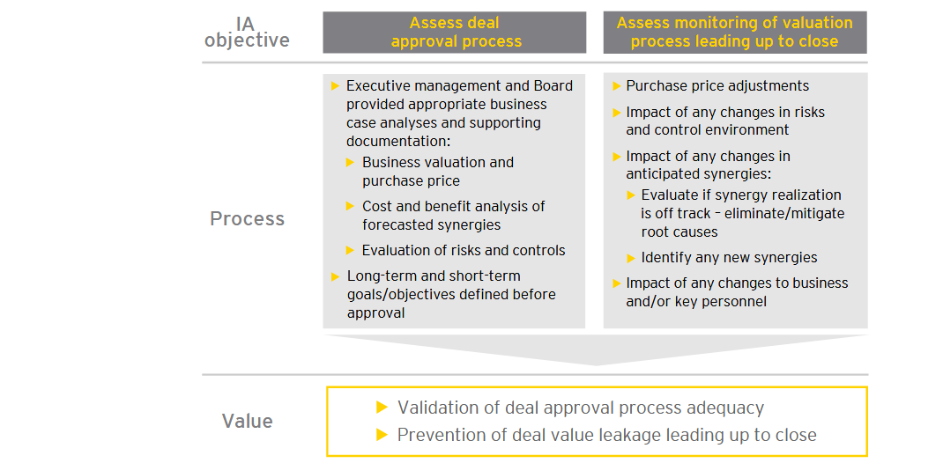

#### Integration

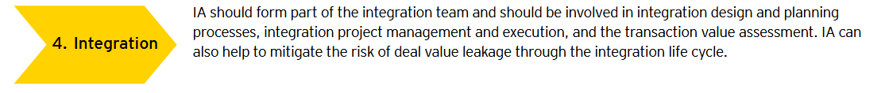

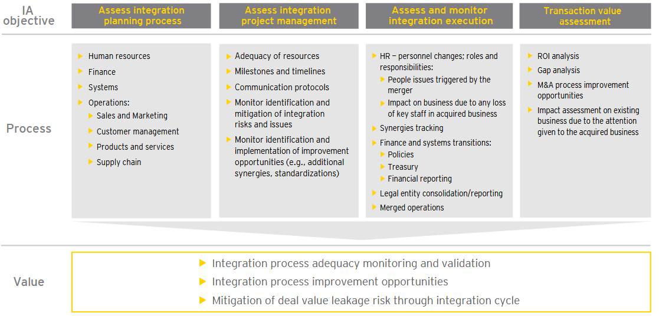

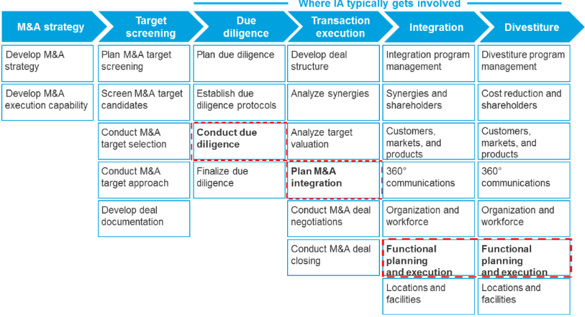

## Audit Agile Projects

**Audit data**: ➊**Development**. Ensure it is planned using agile planning / continuous integration; changes are communicated across teams; environments appropriate & available timely; watch rework following redesign / after bug fixing; watch process to get customer or business change into an assessment: how fast? barriers and points where project fails to perform ➋**Design**. Ensure there IS a design process, no programming hacking without design considerations, design is shared, is performed in agile, change is performed, change is welcomed and encouraged where necessary, daily meetings record element of design changes sufficient for audit ➌**Management**. Ensure delivered using agile approach, commitments are examined, daily meetings taking place, assessments being performed, teams engaged, manager regularly examining team, coaching taking place, all management stakeholders are in place, communicating their commitment, and team is delivering in high performance manner ➍**Process**. Understand if commitments made at the outset are being maintained. Examine how well the agile approach is improving the performance of the project delivery environment and therefore the organisation. **Auditing Guidelines** ➊Audit be non-intrusive ➋Audit not trigger creation of for-Auditor-only documents ➌Generic Scrum checklist tailored to project requirements as basis for audit ➍Auditor is assigned to an entire Sprint per Internal Audit Plan ➎Auditor silent observer of Sprint ➏Auditor added to team mailing list to receive all communications; provided access to all artifacts; attends Sprint Planning, a few Daily Scrum meetings, Sprint Review, Sprint Retrospective meetings. ➐Auditor not schedule formal audit meetings with team members but seek clarifications from ScrumMaster and/or Product Owner during Sprint. ➑Auditors prepare audit report recording their observations and findings against the items in the checklist. Encouraged to go beyond checklist and provide suggestions for improvement. Audit Report presented to Team preferably immediately after Sprint Retrospective meeting. ➒Non-conformances are addressed in forthcoming Sprints and verified by the Auditor.

## Audit AI

**Framework Strategy**: Does the organization have a defined strategy? Is it investing in AI research and development? Does it have plans in place to identify and address AI threats and opportunities? **AI Components** ➊**AI Governance**: structures, processes, procedures implemented to direct, manage, and monitor the AI activities ➋**Data Architecture and Infrastructure**: how data is accessed data is accessible (metadata, taxonomy, unique identifiers, naming conventions)? Information privacy and security throughout the data lifecycle (data collection, use, storage, destruction)? Roles and responsibilities for data ownership & use throughout the data lifecycle? ➌**Data Quality**: completeness, accuracy, and reliability of the data on which AI algorithms are built ➍**AI Performance** ➎**Human Factor**: Risk of unintended human biases factored into AI design is identified and managed ? AI tested to ensure that results reflect the original objective? AI technologies can be transparent given the complexity involved? AI output is being used legally, ethically, responsibly ➏**Black Box Factor**: Type III/Type IV AI technologies — utilizing machines or platforms that can learn on their own or communicate with each other

## Audit Big Data

#### Stakeholders



#### Risk and Control

##### Program governance

**Key Risk:** Lack of appropriate management support, funding, and/or governance over big data program can expose org. to undue risk or failure to meet strategic goals

**Control Activities**

* Funding should be adequate to support business needs.
* Program objectives should support enterprisewide strategy initiatives.
* Management should receive metrics that demonstrate achievement of goals.
* The organization should establish a governing entity to manage the big data strategy.
* There should be agreed-upon SLAs between the business and IT to describe and measure performance expectations.
* Business and technical requirements should be documented, analyzed, and approved.
* Executive management should develop big data strategy that provides solutions across org.
* Prior to approving the business case, management should conduct a proof of concept to validate that the systems designs align with strategic goals.
* Roles and responsibilities should be clear and well defined.
* Organization should provide necessary resources to deploy and maintain the big data strategy.
* Third-party vendor management best practices should be used to manage big data suppliers.

##### Technology availability and performance

**Key Risk:** Ineffective technology solutions and/or configurations may result in a negative customer experience, reduced system availability, and/or degraded performance.

**Control Activities**

* IT operations should be structured in a manner that supports big data service level expectations.
* Data lifecycle policies and procedures should be documented and followed.
* Big data systems should be part of the maintenance strategy.
* Big data systems should be part of the change management strategy.
* Big data systems should be included in the patch management strategy.
* Big data systems should be procured, built, and/or configured in alignment with the complexity and demands documented in the business case.
* Systems and support tools should be configured to provide automatic notifications to support personnel.
* Reporting tools should be configured to be flexible, intuitive, and easy to use; and training aids should be provided.
* Big data systems should be configured to allow flexibility and scalability without sacrificing performance.
* Periodic performance testing should be conducted and weaknesses should be remediated.
* The big data systems lifecycle should be managed properly.
* IT general controls should be assessed periodically

##### Security and privacy

**Key Risk:** Ineffective information security standards and configurations may result in unauthorized access to/ theft of data, inappropriate modifications of data, and regulatory compliance violations

**Control Activities**

* Information security management should be part of the big data strategy.
* Data security management should be part of the big data strategy.
* Third-party access should be managed properly.
* Data privacy should be part of the big data strategy

##### Data quality, management, and reporting

**Key Risk:** Data quality issues and/or inaccurate reporting may lead to inaccurate management reporting and flawed decision making.

**Control Activities**

* Policies and procedures should be established to ensure data quality.
* Policies and procedures should be established to ensure that data obtained from third parties complies with data quality standards.
* Policies and procedures should be established to ensure reporting accuracy.
* Access to reports should be granted based on business needs.
* Reporting tools and procedures should allow for flexibility and ad-hoc reporting.
* Users should be trained periodically to maximize report utility.
* Selection of vendors who provide reporting products & services should align with business needs

## Audit Cloud





#### Security Controls



#### Auditing SAAS

•Customisable reports •Application Functionality Configuration options •Application Security configuration options (aka ERP configurable controls) •User driven data export /interface capabilities •Limited or nil involvement in application development life cycle •CAAT development is challenging •Logs for access controls, Transaction activity, Change management etc. •Existence of myriad of logs •Need automation to map controls to Key Risk Indicators – KRIs •Opportunities to leverage cloud infrastructure - it is more cost effective and efficient to develop on demand , elastic audit databases, implement audit automation





#### Context



#### Risks

➊Account lock-out/resource hijacking? ➋Misconfiguration leading to breach (e.g. S3)? ➌Loss of control? ➍Asymmetries between the provider and customer? ➎Comingling of data / multi-tenancy? ➏Jurisdictional? ➐Who should make risk decisions?

#### Service Layer

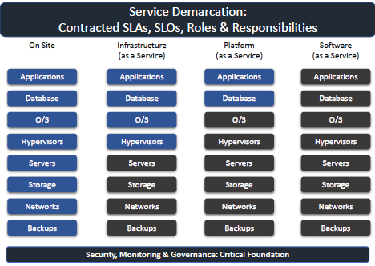

#### IT Functions

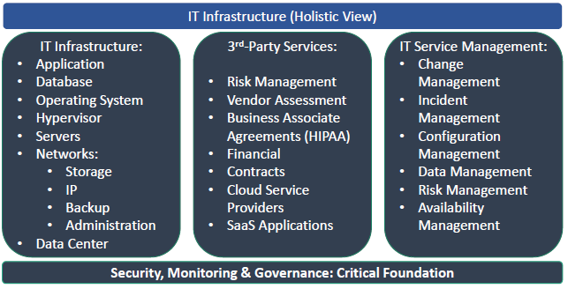

#### Incident Management

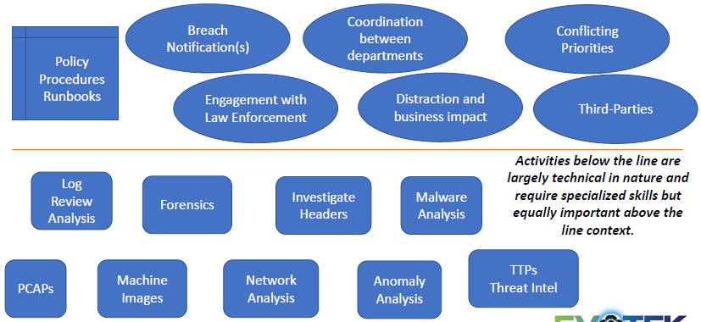

## Audit Cyber Security

#### NIST Cybersecurity Framework

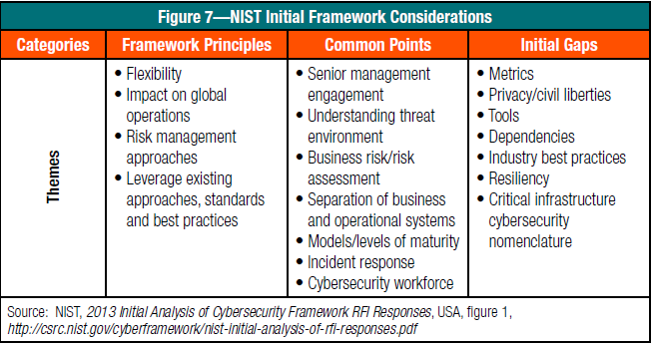

#### CSF vs. COBIT

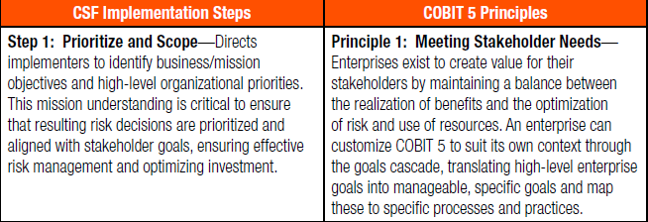

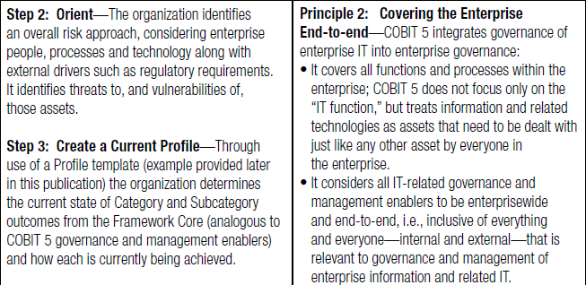

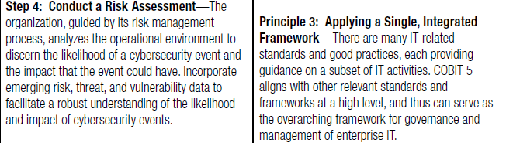

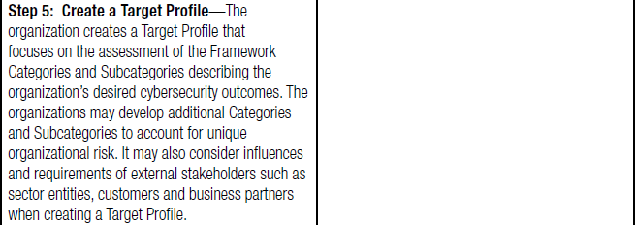

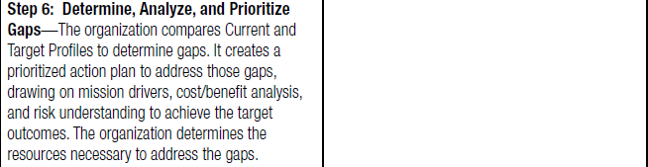

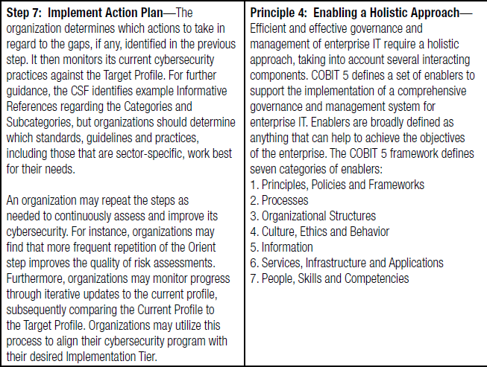

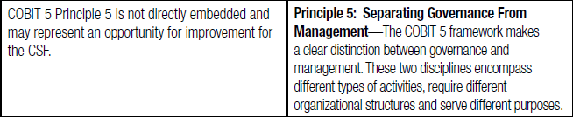

#### Three Lines of Defence

##### First Line of Defense (Management Controls)

* Administer security procedures, training, and testing
* Maintain secure device configurations, up-to-date software, security patches
* Deploy intrusion detection systems and conduct penetration testing
* Securely configure the network to adequately manage and protect network traffic flow
* Inventory information assets, technology devices, and related software
* Deploy data protection and loss prevention programs with related monitoring
* Restrict least-privilege access roles
* Encrypt data where feasible
* Implement vulnerability management with internal and external scans
* Recruit and retain certified IT, IT risk, and information security talent

##### Second Line of Defense (Risk Control & Compliance Oversight)

* Design cybersecurity policies, training, and testing
* Conduct cyber risk assessments
* Gather cyber threat intelligence
* Classify data and design least-privilege access roles
* Monitor incidents, key risk indicators, and remediation
* Recruit and retain certified IT risk talent
* Assess relationships with third parties, suppliers, and service providers
* Plan/test business continuity, and participate in disaster recovery exercises and tests

##### Third Line of Defense (Independent Assurance)

* Provide independent ongoing evaluations of preventive and detective measures related to cybersecurity
* Evaluate IT assets of users with privileged access for standard security configurations, problematic websites, malicious software, and data exfiltration
* Track diligence of remediation
* Conduct cyber risk assessments of service organizations, third parties, and suppliers (note: first and second lines of defense share this ongoing responsibility)

##### Red Flags Signal Potential Governance Gaps

* Disparate, fragmented governance structure
* Incomplete strategy
* Delays of cybersecurity effort
* Budget cuts and attrition
* Unclear resolve to enforce accountability

##### Cybersecurity Risk Assessment Framework

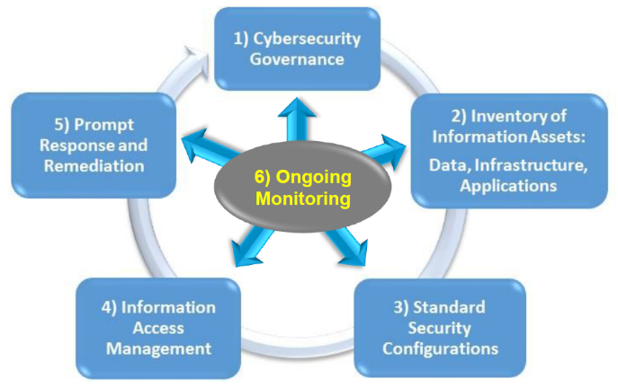

#### Cybersecurity Vulnerabilities, Threats and Risks

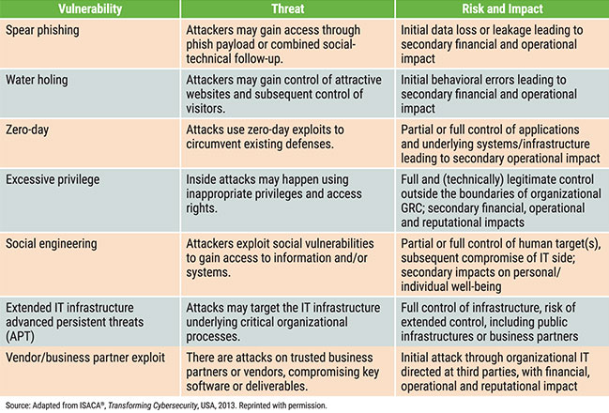

#### Cybersecurity Audit Objectives

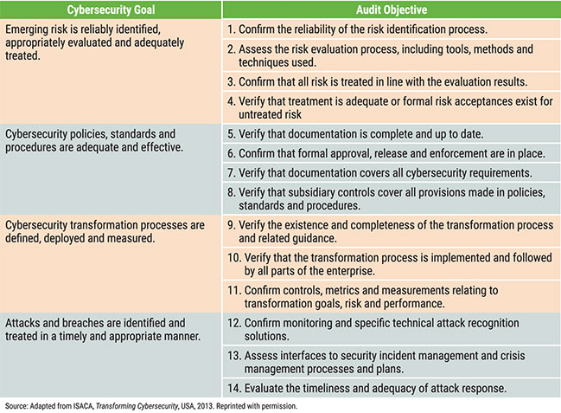

## AUDIT APP CONTAINER

* Risk analysis and management
* Security awareness and training
* Images
* Registry
* Orchestrator
* Application security during development
* Secure connections
* Hardening
* Container destruction

## Audit DEVOPS-CI/CD

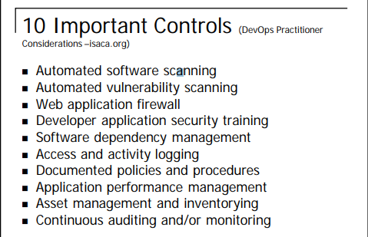

|  |  |  |  |
| --- | --- | --- | --- |
| Control | Purpose | Implementation | Assessment Criteria |
| Automated  software  scanning | A fast release cycle can make it harder to review developed software for security or coding issues. An automated scan during the release process can look for these issues without interrupting the release path | Implement via an automated dynamic or static scanning that triggers as part of the build, testing or release process. Severe issues may warrant further review while lower-priority issues (based on risk tolerance) might be flagged for mitigation in  subsequent releases. | • Observe that application code scanning software is in place and kept current as new attacks are discovered.  • Examine evidence such as log files to ensure that automated code scans are completed as part of release process. |
| Automated  vulnerability  scanning | Tools s.a. Puppet and Chef provide automated configuration anagement  functionality. Changes to configuration can impact the security of production platforms. An automated scan as part of the release process can locate those issues without introducing  a bottleneck. | Implement via an automated vulnerability assessment that triggers as part of the release process. Severe issues may warrant further review while lower-priority issues (based on risk tolerance) might be flagged for mitigation in subsequent releases. | • Observe that vulnerability assessment software is in place and kept current as new attacks are discovered.  • Examine evidence such as log files to ensure that automated vulnerability scans are completed as part of the release process |
| Web application firewall (WAF) or other layer 7 firewall | In situations where application vulnerabilities occur that cannot be remediated quickly, a WAF or other layer 7 firewall (e.g., extensible markup language (XML) firewall or Java virtual machine (VM) firewall) can provide a stopgap to mitigate the onsequences while the underlying issue is remediated. | Implement via use of an in-line proxy filter (e.g., reverse proxy or web server filter) on the web server or in the communication path. | • Observe network architecture diagrams or other documentation to ensure that a WAF or other layer 7 firewall is in place.  • Examine evidence such as log files to ensure that inbound requests are inspected by the WAF or layer 7 firewall. |
| Developer application security training | Because the path between software development and production is streamlined and automated, training can help developers avoid the inadvertent introduction of vulnerabilities | Train developers on secure coding techniques and commonly occurring application vulnerabilities such as the Open Web Application Security Project (OWASP) Top Ten | • Observe the record of attendance or participation in developer focused application security training.  • Observe training materials to ensure that commonly occurring software vulnerability issues are covered.  • Perform a periodic review of software to ensure that developers adhere to recommendations such as OWASP recommendations |
| Software dependency management | Moving to a faster pace of release and automation of build and other intermediate release processes can sometimes make it easier for developers to introduce new dependencies—e.g., new open source or other supporting libraries, new supporting components and middleware or other dependencies | Implementing a process to track these can help offset issues should security or other issues impact supporting components  and libraries. Implement tools and/or processes to inventory, track and/or otherwise manage supporting libraries and underlying application components that might be newly introduced. | • Observe that a process is in place to offset unexpected dependencies.  • Validate that a record of dependencies exists and newly introduced dependencies can be identified. |
| Access and activity logging | Separation of duties under DevOps can be fully realized by automated means (in fact, in some cases with more assurance). However, this depends on logging being enabled and logs being retained. | Implement via logging of access and developer activity that results in changes to production code. Logs should contain, at a minimum, the individual responsible for changes and the time that those changes were made. | • Observe log files to ensure that logging is enabled.  • For a sample of production changes, observe that the change can be mapped back to specific developers.  • Review a sample of historical production changes to ensure that log files are retained |
| Documented policies and procedures | DevOps processes, while automated and alacritous, should still employ rigor and discipline to ensure that security and risk  management goals are met. Having documented policies and procedures describing the release flow is advantageous. | Develop policies and procedures that outline the development and release life cycle. Include policies and procedures in developer training programs. | Review policies to ensure that they exist and cover all aspects of the production release process. |
| Application performance management (APM) | As development and operations processes become more fluid, it is important that applications continue to perform as expected and remain available to stakeholders. | Application performance management tools can help both provide metrics about application performance and flag potential problem areas when/if they occur. Establish a mechanism for tracking application performance and availability. This can encompass APM specific tools (such as commercial or open source APM products) in conjunction with processes that leverage those tools to collect metrics and drive operations tasks. | • Review operations tools to ensure that application performance and availability issues can be identified.  • Review documented processes and procedures to ensure that appropriate personnel are notified or appropriate activities are conducted in light of an issue. |
| Asset management and inventorying | As DevOps accelerates the development process, consider implementing automated or manual methods to retain a record of applications and important information about them:  • Business owner/ purpose  • Domain and subject matter experts  • Physical or virtual location  • Supporting controls and countermeasures | Utilize either an automated tool or manual processes to maintain a record of applications and supporting information about them. Establish tools and/or processes to ensure that this information is kept current and updated. | • Observe tools and/or processes used in support of the application asset management goals to ensure that they are operational.  • Review the master inventory for accuracy; e.g., review a sample of applications on the inventory to ensure that entries are accurate and complete. |
| Continuous auditing and/ or continuous monitoring | Moving to a more real-time and ongoing validation of controls can enable the organization to ensure that controls continue proper operation and that ountermeasures are performing as expected. | Establish a process and supporting tools to continuously validate proper operation of controls. | • Observe mechanisms used to collect information about the control operation.  • Validate that coverage is sufficient to address all applications and environments in scope.  • Observe a record of data collected to ensure that output is complete and accurate. |

## AUDIT SAP

|  |  |
| --- | --- |
| **SAP R/3 REVENUE BUSINESS CYCLE**   * Master Data Maintenance * Sales Order Processing * Shipping, Invoicing, Returns and Adjustments * Collecting and Processing Cash Receipts   **SAP R/3 EXPENDITURE BUSINESS CYCLE**   * Master Data Maintenance * Purchasing * Invoice Processing * Processing Disbursements   **SAP R/3 INVENTORY BUSINESS CYCLE**   * Master Data Maintenance * Raw Materials Management * Producing and Costing Inventory * Handling and Shipping Finished Goods   **SAP R/3 BASIS APPLICATION AND TECHNICAL INFRASTRUCTURE**   * SAP R/3 Architecture * SAP R/3 Basis Application Infrastructure * Audit Implications | **AUDITING SAP R/3 REVENUE BUSINESS CYCLE**   * Master Data Maintenance * Sales Order Processing * Shipping, Invoicing, Returns and Adjustments * Collecting and Processing Cash Receipts   **AUDITING SAP R/3 EXPENDITURE BUSINESS CYCLE**   * Master Data Maintenance * Purchasing * Invoice * Processing Disbursements * Testing Techniques   **AUDITING SAP R/3 INVENTORY BUSINESS CYCLE**   * Master Data Maintenance * Raw Materials Management * Producing and Costing Inventory * Handling and Shipping Finished Goods   **AUDITING SAP R/3 BASIS APPLICATION INFRASTRUCTURE**   * Installation Management Guide * Organization Model * Critical Number Ranges * Modifying Critical Tables * ABAP/4 Workbench/ Transport System * Customizing and Executing ABAP/4 Programs * ABAP/4 Development in Production * Data Dictionary Changes * Queries Company Code Setting * Computer Center Management System * Profile Generator and Security Administration * Case Study |

## ISACA AUDIT IF

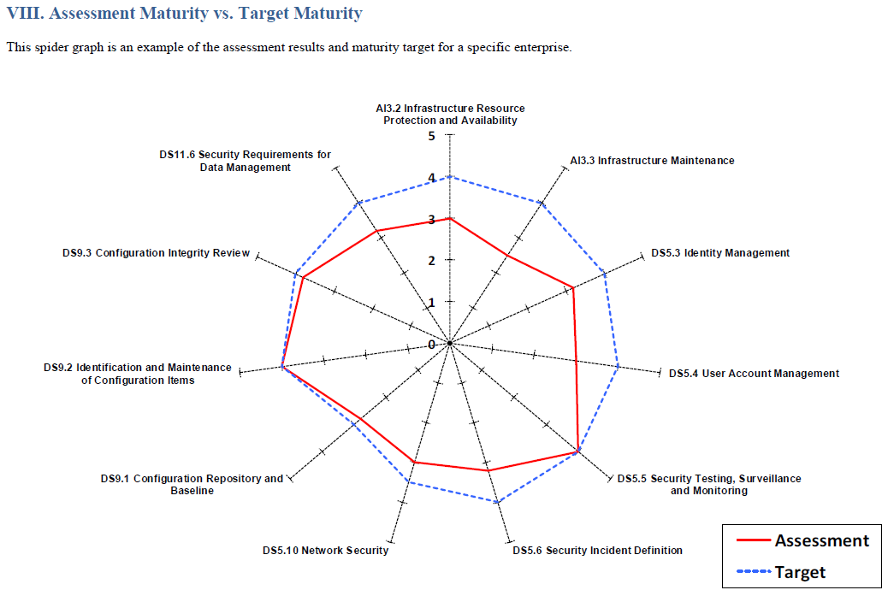

## COBIT

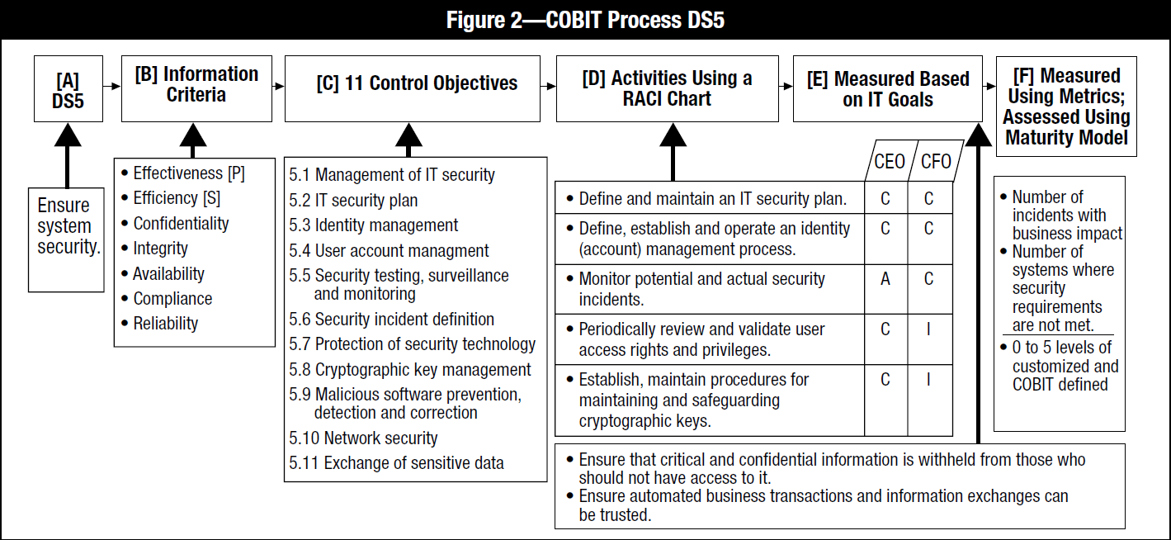

## PCI-DSS

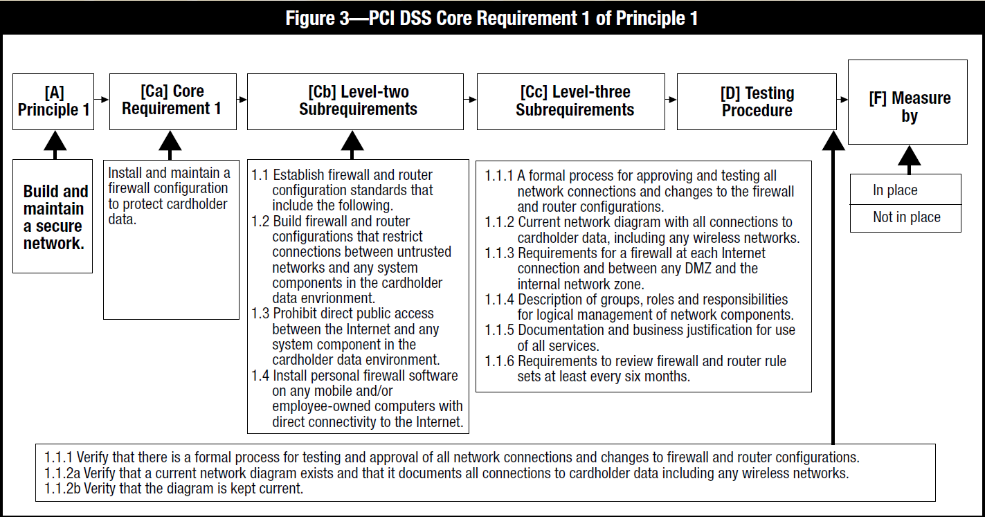

## AWS PCI-DSS WORKBOOK

|  |  |  |
| --- | --- | --- |
| REQUIREMENT | AWS RESPONSIBILITY | CUSTOMER RESPONSIBILITY |
| Requirement 1: Install and maintain a firewall configuration to protect cardholder data. | • All In-Scope Services: AWS maintains instance isolation for host operating systems and the AWS Management Environment including host operating system, hypervisor, firewall configuration, and baseline firewall rules.  • AWS meets all requirements for implementing and managing firewalls for the AWS management environment.  • Amazon EC2 and Amazon ECS: Amazon VPC Security Groups and network ACLs implement stateful inspection network access control and are suitable for compliant network segmentation | • Amazon EC2 and Amazon ECS: AWS customers are responsible for security group definitions and network access control rules. |
| Requirement 2: Do not use Supplier-supplied defaults for system passwords and other security parameters. | • All In-Scope Services: AWS develops and maintains configuration and hardening standards for the AWS Management Environment that provides the virtualization technologies and applications for providing cloud services.  • AWS maintains configuration and hardening standards for the underlying operating systems and platforms for these services. | • Amazon EC2 and Amazon ECS: AWS customers are responsible for changing default vendor configurations, security controls, and vendor default passwords.  • All In-Scope Services: AWS customers are responsible for secure and compliant configuration for all customer-configurable items. This may include OS configuration for Amazon EC2 and Amazon ECS instances, logging and log retention for data base services, or permissions for AWS management functions. |
| Requirement 3: Protect stored cardholder data. | • All In-Scope Services: AWS Key Management Service (AWS KMS) secures keys using hardware security modules and provides functions to use and manage keys.  • AWS CloudHSM secures keys and provides cryptographic functions using customer-dedicated hardware security modules. | • Amazon EC2 and Amazon ECS: AWS customers are responsible for changing default vendor configurations, security controls, and vendor default passwords.  • All In-Scope Services: AWS customers are responsible for implementing encryption on all applicable internal and external network connections. (This may require use of AWS optional API encryption).  • AWS KMS and AWS CloudHSM: AWS customers are responsible for the creation, usage, and management of encryption keys in accordance with PCI Data Security Standards. |
| Requirement 4: Encrypt transmission of cardholder data across open, public networks. | • All In-Scope Services: AWS encrypts access and manages encryption within the AWS Management Environment. | • All In-Scope Services: AWS customers are responsible for implementing encryption on all applicable internal and external network connections. (This may require use of AWS optional API encryption). |
| Requirement 5: Use and regularly update anti-virus software or programs. | • All In-Scope Services: AWS manages anti-virus software for the AWS Management Environment and, where appropriate, for identified services. | • Amazon EC2 and Amazon ECS: AWS customers are responsible for implementing anti-virus software on customer-managed OS instances commonly subject to malware. |
| Requirement 6: Develop and maintain secure systems and applications. | • All In-Scope Services: AWS maintains security patching, development, and change control of the applications that support the services included in the assessment including web interfaces, APIs, access controls, provisioning, and deployment mechanisms.  • AWS develops and manages changes to applications that support the services included in the assessment including web interfaces, APIs, access controls, provisioning, and deployment mechanisms. | • Amazon EC2 and Amazon ECS: AWS customers are responsible for monitoring published OS and application vulnerabilities and patching on instances.  • Customers are required to use documented change control for all configurations and customer code.  • Customers who develop custom code that is used to transmit, process, or store credit card data must comply with requirements for secure development and testing.  • AWS Web Application Firewall (AWS WAF): Customers are responsible for protecting their web applications from common web exploits. This includes (but not limited to) configuring access control lists and web application firewall rules for filtering traffic to and from their web applications. |
| Requirement 7: Restrict access to cardholder data by business need-to- know. | • All In-Scope Services: AWS maintains the access controls related to underlying infrastructure systems and the AWS Management Environment. | • Amazon EC2 and Amazon ECS: AWS customers are responsible for access control within all OS instances.  • All In-Scope Services: AWS customers are responsible for configurable access controls within the services such as database users within Amazon RDS.  • AWS IAM & AWS Credentials: AWS customers are responsible for managing access to all AWS services that are included in their CDE. AWS IAM can be used to configure resource management and AWS configuration roles and permissions. Customers are responsible for configuring AWS account and session controls to meet PCI requirements. Customers must be aware of AWS guidelines for credentials and access control for AWS resource management. |
| Requirement 8: Assign a unique ID to each person with computer access. | • All In-Scope Services: AWS provides each user in the AWS Management Environment a unique ID.  • AWS provides additional security options that enable AWS customers to further protect their AWS Account and control access: AWS Identity and Access Management (AWS IAM), Multi-Factor Authentication (MFA), and Key Rotation. | • Amazon EC2 and Amazon ECS: AWS customers are responsible for access control within all OS instances.  • All In-Scope Services: AWS customers are responsible for configurable access controls within the services such as database users within Amazon RDS.  • AWS IAM & AWS Credentials: AWS customers are responsible for managing access to all AWS services that are included in their CDE. AWS IAM can be used to manage resource management and AWS configuration roles and permissions. Customers are responsible for configuring AWS account and session controls to meet requirements. Customers must be aware of AWS guidelines for credentials and access control for AWS resource management. |
| Requirement 9: Restrict physical access to cardholder data. | • All In-Scope Services: AWS maintains the physical security and media handling controls for the services included in the assessment. | • All In-Scope Services: Any media created outside of the AWS environment is the sole responsibility of the customert |
| Requirement 10: Track and monitor all access to network resources and cardholder data. | • All In-Scope Services: AWS maintains and monitors audit logs for the AWS Management Environment and AWS service infrastructure. | • Amazon EC2 and Amazon ECS: AWS customers are responsible for logging within all OS instances.  • AWS IAM & AWS Console: User activity logs of resource management activities via the console and command line are available to users via Amazon AWS CloudTrail. Amazon AWS CloudTrail must be used to record and monitor AWS resource management activities.  • Amazon S3: Users are responsible for configuring bucket logging and monitoring logs.  • Amazon RDS & Amazon Redshift: Users are responsible for configuring database access logging and monitoring logs.  • Amazon EMR: Customers using Amazon EMR to store cardholder data are responsible for logging access.  • Amazon SimpleDB & Amazon DynamoDB: Customers using these databases are responsible for access logging.  • AWS Config: Customers using AWS Config to store configuration data and resource inventory are responsible for access logging and monitoring logs.  • AWS WAF: Customers using AWS WAF to protect public facing applications including application databases that store cardholder data are responsible for logging access and monitoring logs.  • Elastic Load Balancing: Customers using Elastic Load Balancing can monitor applications in real time integrating with Cloud Watch.  • All In-Scope Services: AWS customers are responsible for configuration of logging within the services. AWS CloudTrail can be used to log all AWS API calls.  • Customers are responsible for monitoring logs for security events. Log monitoring may be implemented with CloudWatch or 3rd party services. |
| Requirement 11: Regularly test security systems and processes. | • All In-Scope Services: AWS manages rogue wireless access point detection, vulnerability and penetration testing, intrusion detection, and file integrity monitoring for the AWS Management Environment and the identified services.  • AWS implements and monitors IDS/IPS on networks that implement AWS services. | • Amazon EC2 and Amazon ECS: AWS customers are responsible for internal and external scanning and penetration testing of their instances and virtual networks. Customers must follow AWS processes for scanning and penetration testing: http://aws.amazon.com/security/penetration-testing/.  • AWS customers are responsible for implementing IDS functionality typically using Host-based IDS (HIDS) on network segments they implement and manage. |
| Requirement 12: Maintain a policy that addresses information security for employees and contractors. | • All In-Scope Services: AWS maintains security policies and procedures, security awareness training, security incident response plan, and human resource processes that align with PCI requirements. | • All In-Scope Services: AWS customers are responsible for all policies and procedures. AWS customers should include AWS as an infrastructure provider for Req. 12.8. Alerts from AWS should be part of the IRP for Req. 12.10. |
| Requirement A1: Shared hosting providers must protect the cardholder data environment. | • All In-Scope Services: AWS customer instances and data are protected by instance isolation and other security measures in the AWS Management Environment. | • All In-Scope Services: AWS customers may also be considered a shared hosting provider if they run applications or store data for their customers. In this case, customers are responsible for protecting their customer’s data within AWS services. |
| Appendix A2: Additional PCI DSS Requirements for Entities using SSL/Early TLS for Card-Present POS POI Terminal Connections | • This appendix concerns on-premise, point-of-sale terminals and is not applicable to AWS.  • However, the use of TLSv1.1 and/or v1.2 is required, and AWS fully supports these protocols. | • All In-Scope Services: AWS maintains TLSv1.1 or greater to support customer's PCI workloads. AWS provides a minimum-security policy of TLSv1.0 for customers with non-PCI workloads that still require it. AWS customers are responsible for initiating TLS connections that use TLSv1.1 or greater for PCI compliance. |

## ON-BOARDING

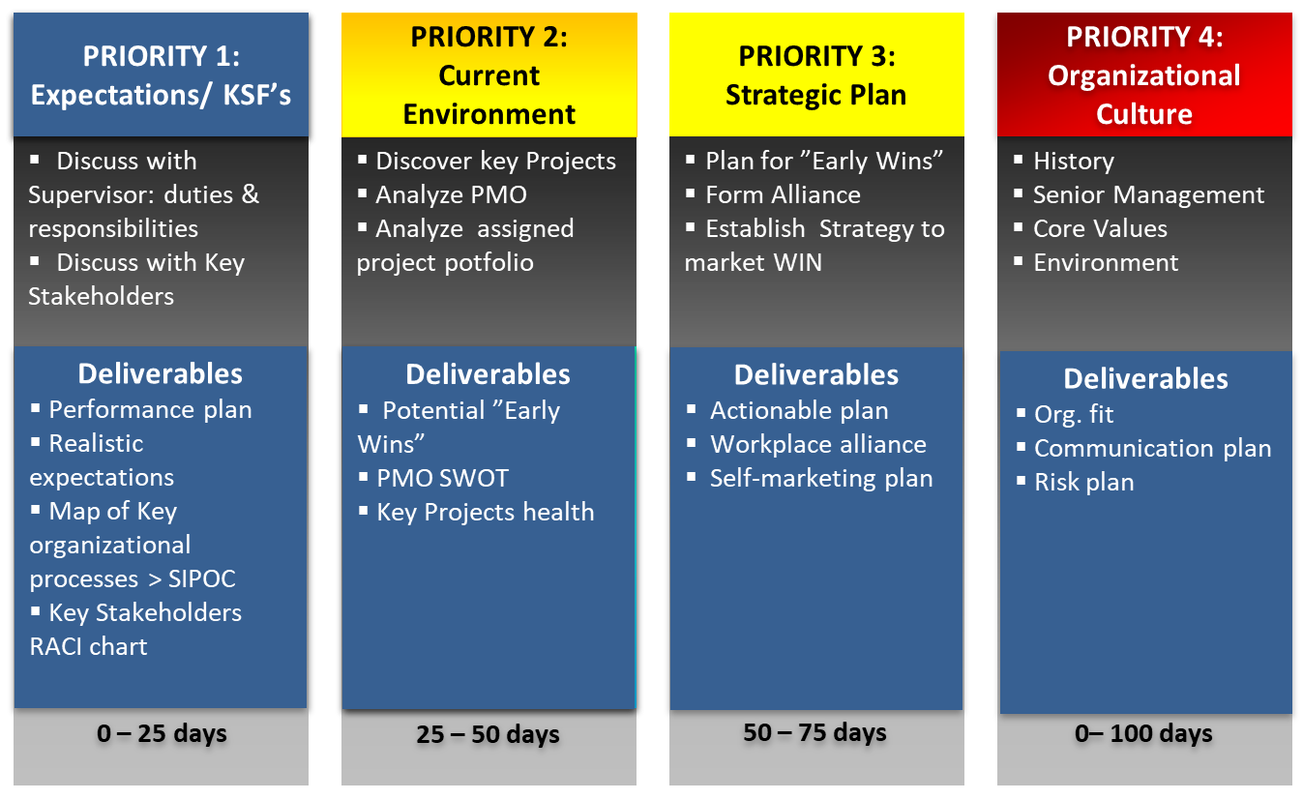

# CIBC Control

## CIBC 20 Services (Financial)

|  |  |
| --- | --- |
| AUDIT | Admin of Non-Core loans. |
| FINANCE | Advertisement Costs |
| GLOBAP OPS | AR, AP |
| HR | Business Analysis |
| LEGAL | Call Centre Supports products for Commercial Banking |
| MARKETING | Compliance |
| RETAIL | Fees (Directors, OSFI) |
| RISK | Financial Analysis |
| TECH SERV | Financial Ombudsman |
| WORLD MARKETS | Financial Risk Support |
| WEALTH | HR - Compensation |
|  | HR - Compliance |
|  | Management Costs |
|  | Project Management |
|  | Resource Centre - reports (M&A, Green sheets, Prospectus') and internet searches |
|  | Stock services |
|  | TI/TS Application Support Cost |
|  | TI/TS Technology Services Cost |

## CIBC Processes (FCU)

|  |  |
| --- | --- |
| **BUSINESS_PROCESS** | **SUB_PROCESS** |
| A/P | Accrual |
| Interco loan | Account for loan payable to treasury |
| Outstanding Cheques Clearing | Accounting Outstanding Cheques |
| Accrue Liabilities | ID significant individual liabilities |
| Accrue Obligations related to Securities | Record Repos Position |
| Record Securities Sold Short Position |
| Calculate/ Collect Mortgage Income | Originate a mortgage - recording of acquisition costs on mortgage origination |
| Income Taxes Note Disclosure | Compilation of Note Disclosure |
| Note Disclosure Aging of Deposits | Demand, Notice & Term Deposits |
| Note Disclosure IR Sensitivity | Loans & Deposits Aging & yields |
| Note Disclosure Mortgage and customer Loans | Mortgages & Consumer Loans |
| Note Disclosure Segment info | Establish customer CIF (name, address, & permanent information) |
| Defer Acquisition Cost on Mortgages | Calculate/invoice acquisition cost |
| Prepare amortization schedule |
| Defer Payments to Loblaws | Defer Acquisition Cost of acquiring credit products and points |
| EUC Applications | General Controls |
| Financial Statements Preparation | Compilation of Notes to the Financial Statements |
| Get a mortgage loan on the books | Funding Mortgages |
| Get the Loans on the books | Attach credit - PLC |
|  | Disburse Funds for Personal Loans |
| GL/source system balancing | Automatically compare ICBS and GL:M balances |
| HR | Bi-weekly review of payroll register (Including New Hire, Transfers, and Terminations) |
| ICBS Application Controls | AS400 Recovery |
|  | Change Management |
|  | ICBS Incident & Problem Management Process |
| ICBS Information Security | Security Administration |
| Maintain customer demand (chequing) deposit | Calculate and accrue daily interest |
| Maintain interest rates |
| Transaction Cheque Clearing |
| Transaction processing - EFT |
| Transaction processing - POS, ABM, Internet, TB - on Tandem |
| Maintain customer loan | Maintain interest rates in ICBS |
|  | Recognize interest calc & accrual |
|  | Transaction Processing - Payments or PLC cheques |
| Maintain customer notice (RSP) deposits | RSP Renewal |
| Maintain customer notice(savings) deposit | Transaction processing - Internet, ABM, TB (transfers only) - on Tandem |
| Maintain residential mortgages | All sub-process |
|  | Apply payments to Int. income and principal / Accrue Int. at month-end |
|  | Determine mortgage interest rates |
| Manage Bank Accounts | Balance & Settle A/P Bank Account |
|  | Balance & Settle ABM Unpostable, All EFT Return Bank Accounts |
|  | Balance & Settle ABM, POS, RB, SCD, Plus, Outbound EFT Bank Accounts |
|  | Balance & Settle Cheque Clearing |
|  | Balance & Settle EFT Bank Account |
|  | Balance & Settle General Operating, Treasury, Mortgage, EFT, USD Bank |
|  | Balance & Settle Guarantee Payments Bank A/C Drafts & MO |
|  | Balance & Settle Guarantee Payments, Cheq Clr Bank A/C Loans |
|  | Balance & Settle Payroll Bank |
|  | Balance & Settle Treasury Bank A/C |
| Manage Suspense Accounts | Manage Operating Suspense A/C |
| Other Misc Suspense Accts | Accounting Items in Suspense A/C |
| Purchase & pay for non interest expenses | Pay Outside Services (Amortized Trailer fees / Commissions) |
| Pay Other Misc Expenses |
| Purchase & pay other expenses | Pay Other Expenses |
| Recognize deferred taxes | Book Monthly Tax Recovery |
|  | Determine monthly tax rate - Acct |
| Recognize fee income | Recognize Amicus ABM Surcharge |
|  | Recognize Interac Charges (convenience fee auto charged for each customer txn) |
|  | Recognize Returned Cheque Fees |
| Recognize FOREX non-trading income | Recognize other income |

## CIBC 26 Processes (OPC) – 113 Sub-processes

|  |  |
| --- | --- |
| **Process** | **Sub Process** |
| Brokerage & Trade | Broker Services - Cash Processing |
| Broker Services- Collateral Management |
| Cash Management |
| Cash Management - Collection of Foreign Cheques |
| Cash Management-Cheque Issuance |
| Cash Management-Incoming wire payments/Cheque deposits |
| Cash Management-ISI Liasion Desk/Bank Reconciliation-Break Resolution |
| CP Issuance - Billing |
| CP Issuance - Book Based Maturity |
| CP Issuance - Physical Maturity |
| CP Issuance-DCS Settlement |
| CP Issuance-Physical Settlement |
| Domestic Equity /Bonds Settlements |
| Equity Arbitrage |
| Futures & Options Settlements |
| GIC Settlements |
| Institutional Equity Settlements - Equity Arbitrage |
| International Settlements |
| Money Market |
| Money Market DTC/FED Settlements |
| Money Market US Settlements- Physical Trades |
| Over The Counter Receipt of Securities |
| Over The Counter/Branch Receipt of Securities |
| Safekeeping |
| Security Lending and Borrowing |
| Segregation Management |
| Stock Transfers |
| UK Securities Lending |
| Compliance | COB Disclosure |
| Credit Mgt | Monitor Credit |
| Customer Satisfaction | Customer Complaints Management |
| Customer Restitution |
| Derivatives Settlement Operations | Confirmations |
| Post-Settlement Investigations |
| Pre-Settlement Investigations |
| Settlements |
| Foreign Exchange | Booking |
| Maintenance | Account Information Maintenance |
|  | Customer Information Maintenance |
|  | Operator Profile Maintenance |
|  | Suspense Account Maintenance |
| Manage and Monitor the Imperial vehicles | Execute Transactions |
| Identify Substitute and Replacement Assets |
| Reporting |
| Management Processes | Investments |
| Lending |
| Procedures Information |
| Regulatory Compliance |
| Sales Management |
| Origination | Adjudication |
|  | Application Processing |
|  | Funding & Disbursement |
| Origination (Commercial) | Adjudication (Commercial) |
| Funding & Disbursement (Commercial) |
| Outsourcing | Outsourcing - ADP |
| Payments Processing | Cash Settlements |
| Credit Administration |
| Investigations |
| Reports Balancing |
| Sanction Filtering |
| Validation & Message Repair |
| Portfolio Management | Credit Derivative Hedging |
| Credit Derivative Trading |
| Establish Portfolio Strategy |
| Hedging |
| Portfolio Management |
| Proprietary Products | Account Maintenance (CM, Talvest and SI only) |
| Account Opening (PPS) |
| Account Opening/Closing/Transfers (CM/Talvest only) |
| Client Tax Reporting / Tax filing |
| Financial Transactions/ Adjustments |
| Trust Accounting |
| Registered Products | 3rd Party Settlements - Brokerage |
| 3rd Party Settlements-Fixed Term |
| Account Transfers (Internal)-Fixed Term |
| Adjustments - Brokerage |
| Adjustments-Fixed Term |
| Client Support-Fixed Term |
| Deposits-Fixed Term |
| GL Reporting-Fixed Term |
| Monitoring & Compliance - Brokerage |
| Tax Reporting - Brokerage |
| Tax Reporting (GIC Withdrawals)-Fixed Term |
| Transfers - Brokerage |
| Withdrawals- Brokerage |
| Withdrawals-Fixed Term |
| Sales Fulfillment | Lending - Personal Loan Products |
|  | Lending - Small Business Loan Products |
|  | Small Business Account |
| Sales Origination | Account Open - Personal Deposits |
|  | Account Open - Small Business Deposits |
| Security &Control | CSP Application Processing |
|  | Database Control |
| Service - Inventory Control | Ordering |
| Servicing | Annual Statement |
| Call Center |
| Discharge |
| Early Renewals |
| Product Changes |
| Renewals |
| Taxes |
| Transaction Processing |
| Servicing (Commercial) | Annual Portfolio Review |
| Renewals (Commercial) |
| Transaction Processing (Commercial) |
| Technology Mgt | IT Access Control |
| 3rd Party Mutual Funds | Processing |
| Trade Finance | Documentation Verification |
| Transaction Processing | Centralized Instruments Processing |
| Cheque Processing |
| Deposit Processing |
| Inter Branch Payments (IBP) Processing |
| Withdrawal Processing |
|  |  |

## Audit Lifecycle

